<https://www.youtube.com/watch?v=qcvAqAH60Yw&list=PLblh5JKOoLUICTaGLRoHQDuF_7q2GfuJF&index=7>

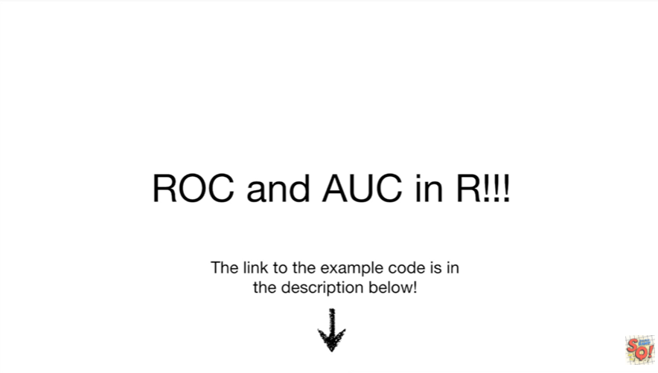

Today we're gonna talk about drawing ROC graphs and calculating the AUC in R.

If you're interested in doing this at home there's a link to the example code in the description below.

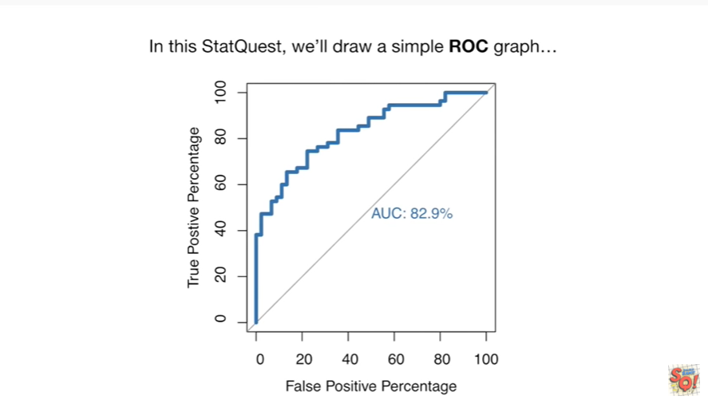

In this stack quest we'll draw simple ROC graph

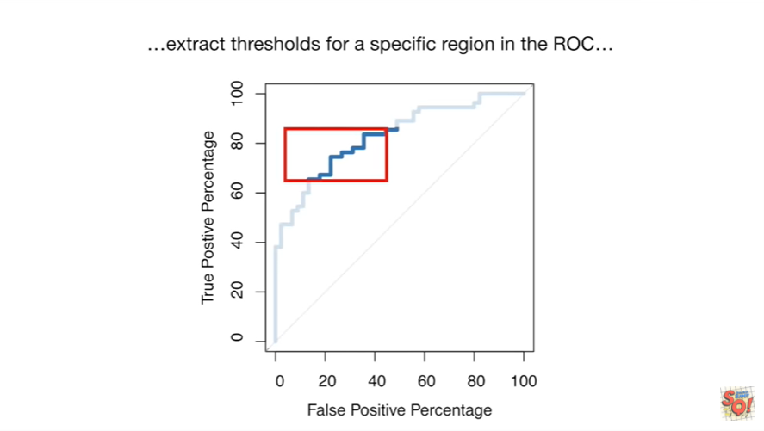

extract thresholds for a specific region in the ROC

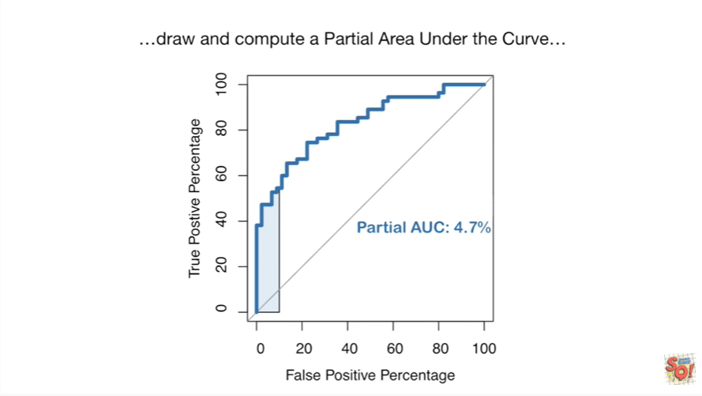

draw and compute a partial area under the curve

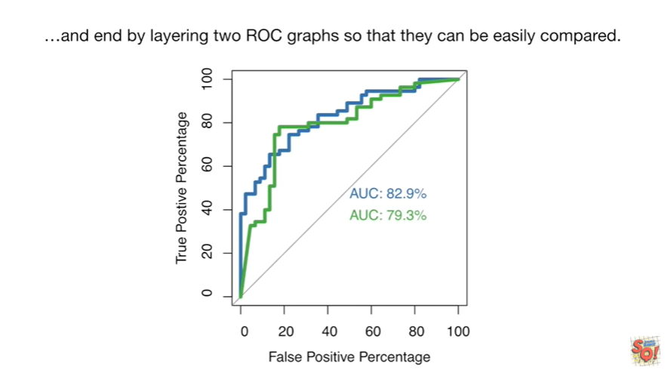

and end by layering two ROC graphs so that they can be easily compared.

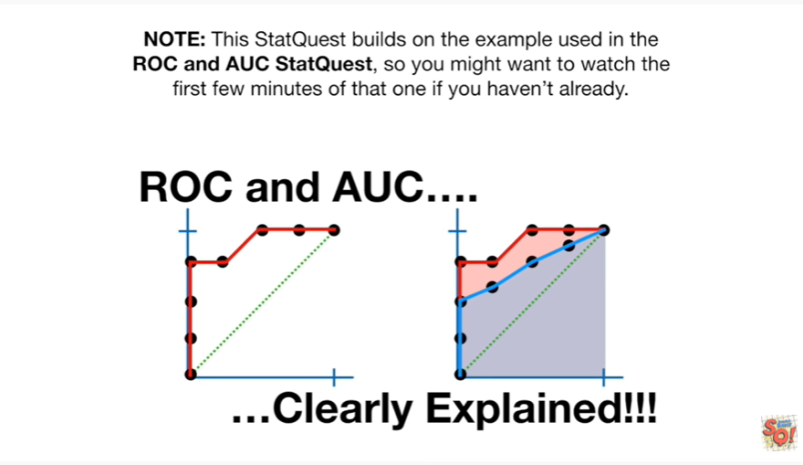

Note : this stack quest builds on the example used in the ROC and AUC stack quest so you might want to watch the first few minutes of that one if you haven't already.

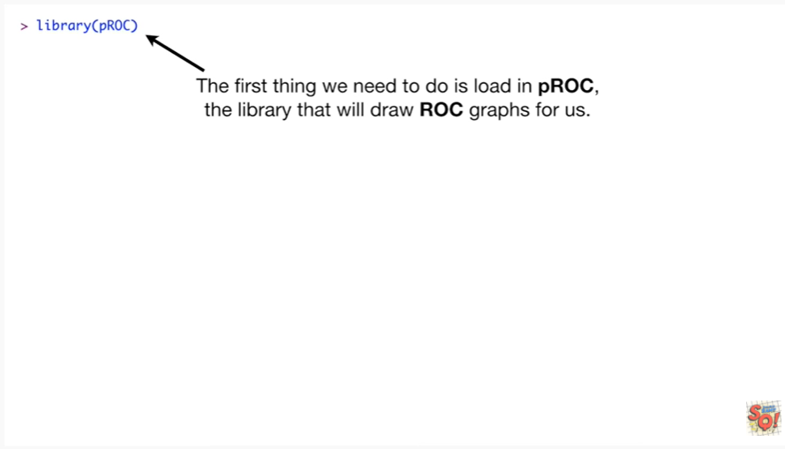

The first thing we need to do is load in PR OC the library that will draw ROC graphs for us.

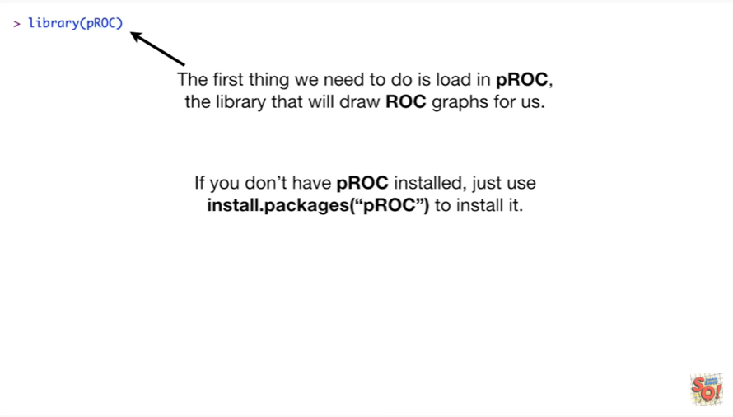

If you don't have P ROC installed, just use installed out packages PR OC to install it.

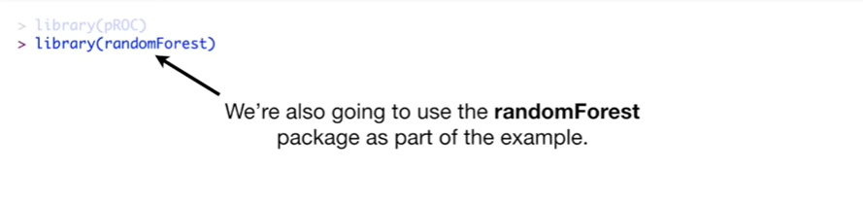

We're also going to use the random forests package as part of the example.

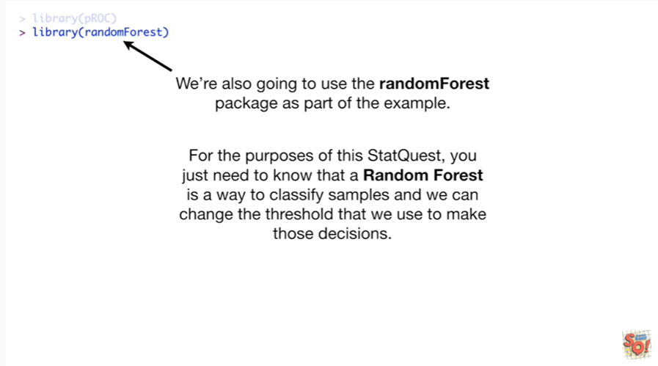

For the purposes of this stack quest you just need to know that a random forest is a way to classify samples and we can change the threshold that we use to make those decisions.

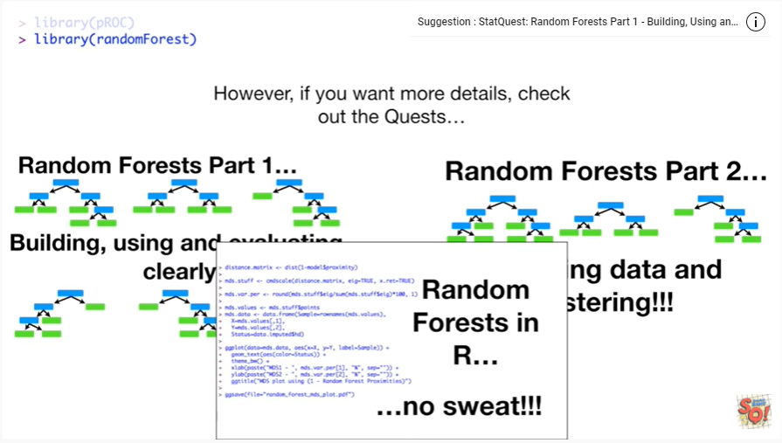

However if you want more details check out the quests.

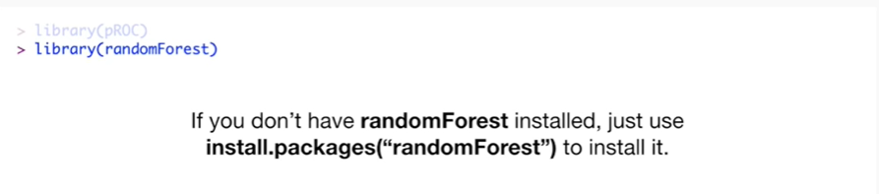

If don't have random forests installed just use install dot packages random forests to install it.

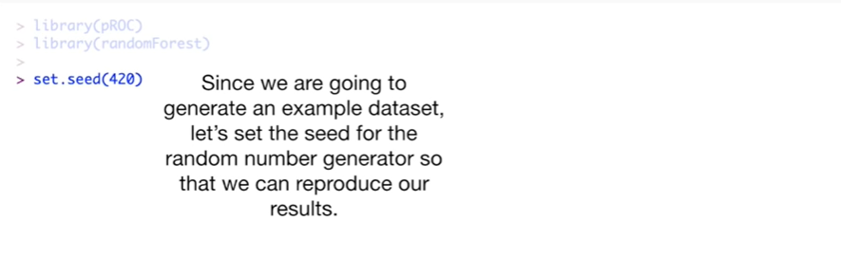

Since we are going to generate an example dataset let's set the seed for the random number generator so that we can reproduce our results.

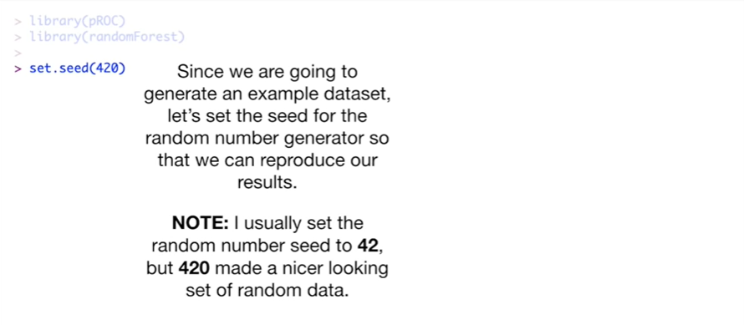

Note I usually set the random number seed to 42 but 420 made a nicer looking set of random data.

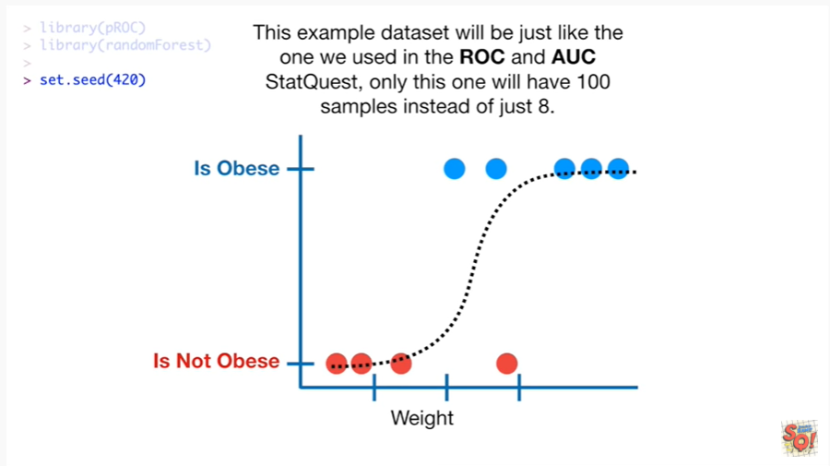

This example dataset will be just like the one we used in the ROC and AOC stat quest only this one will have 100 samples instead of just eight.

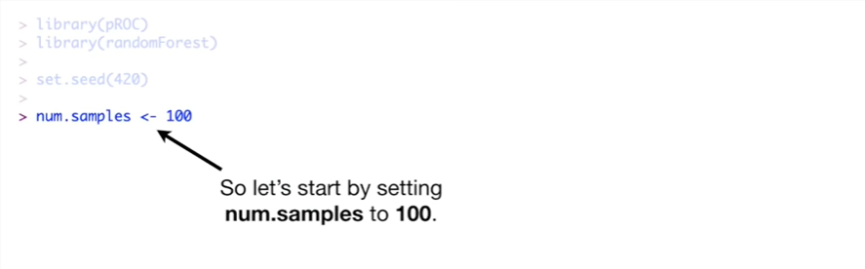

So let's start by setting num dots ampuls to 100.

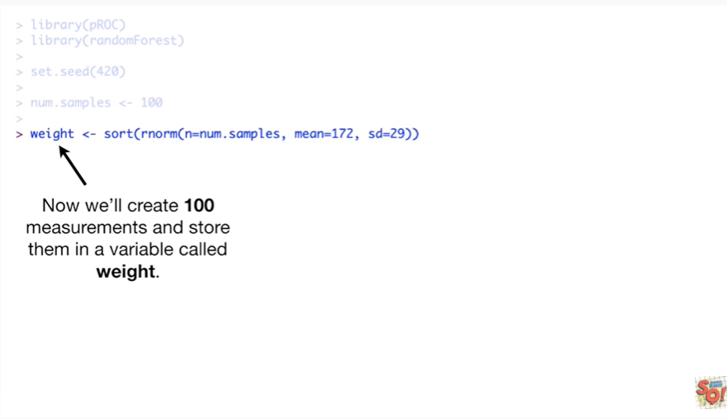

Now we'll create 100 measurements and store them in a variable called weight.

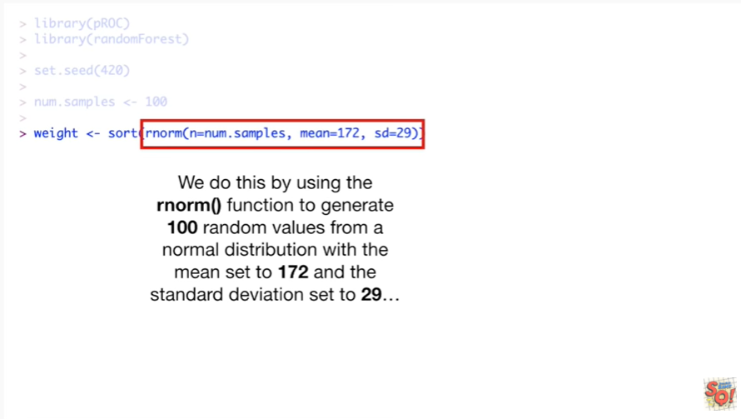

We do this by using the R norm function to generate 100 random values from a normal distribution with the mean set to 172 and the standard deviation set to 29.

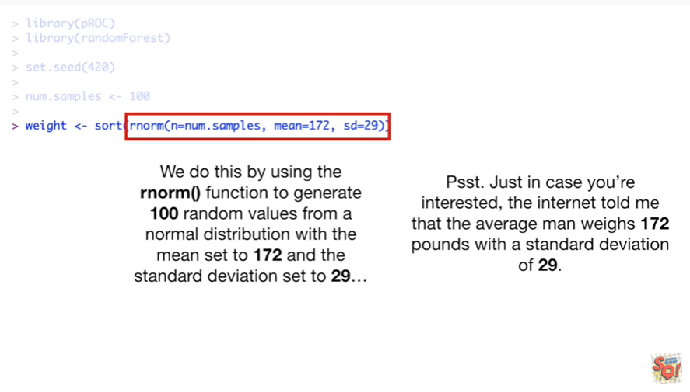

Psst, just just in case you're interested the internet told me that the average man weighs 172 pounds with a standard deviation of 29.

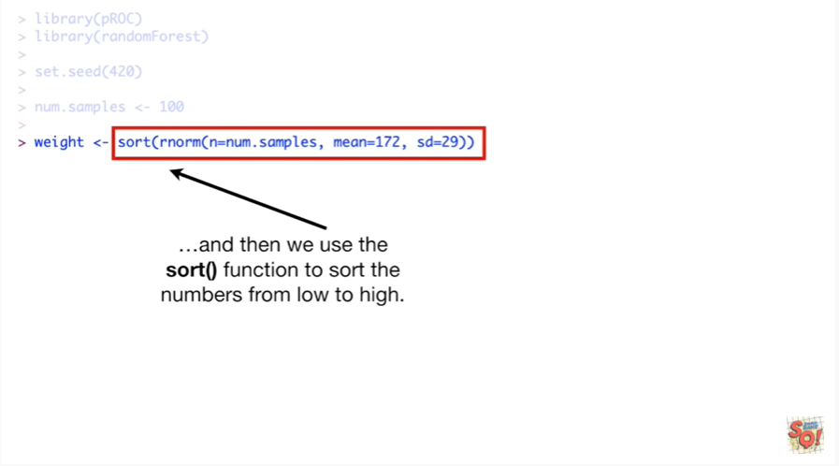

And then we use the sort function to sort the numbers from low to high.

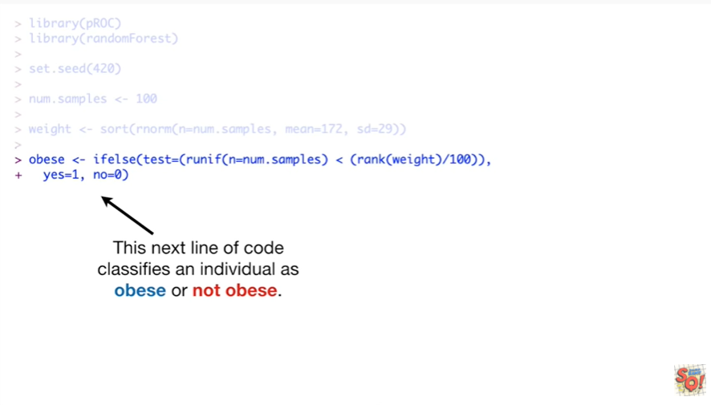

This next line of code classifies an individual as obese or not obese.

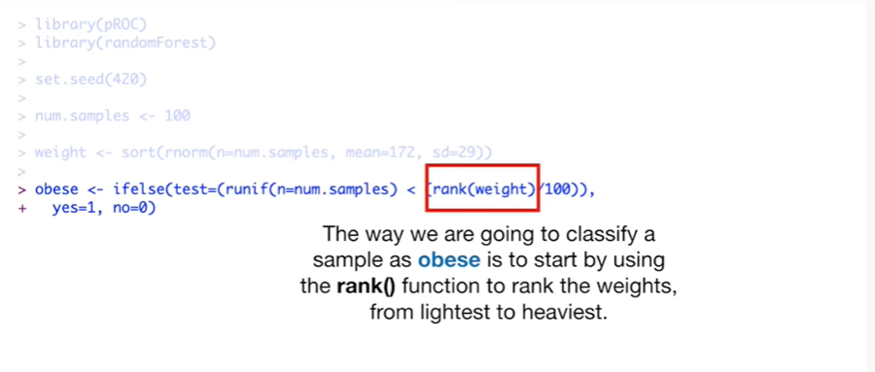

The way we are going to classify a sample as obese is to start by using the rank function to rank the weights from lightest to heaviest.

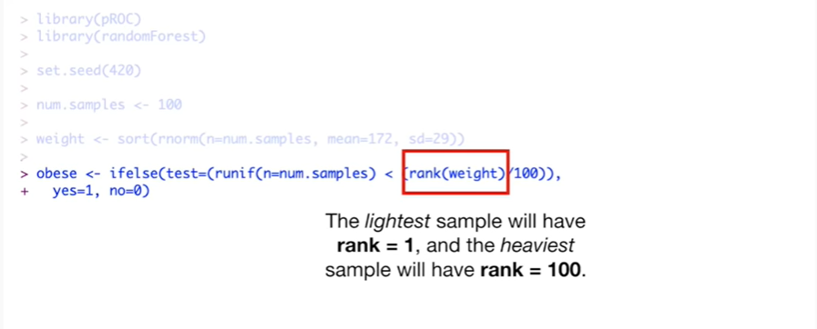

The lightest sample will have rank equals 1 and the heaviest sample will have rank equals 100.

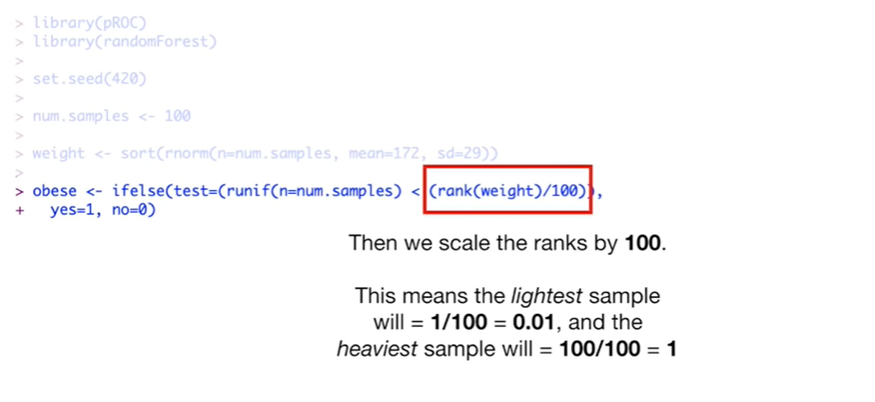

Then we scale the ranks by 100 this means that the lightest sample will equal 1 divided by 100 which equals 0.01 and the heaviest sample will equal 100 divided by 100 which equals 1.

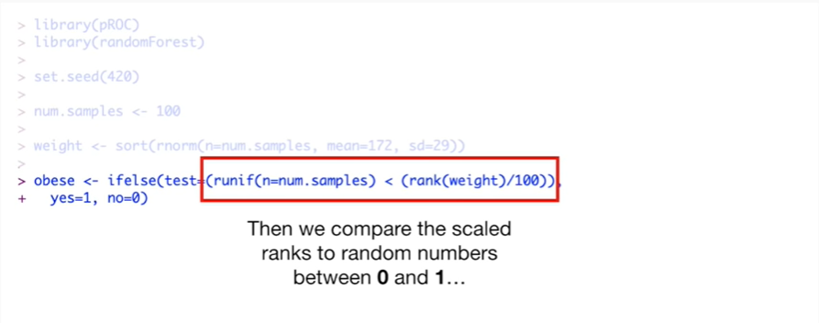

Then we compare the scaled ranks to random numbers between 0 & 1

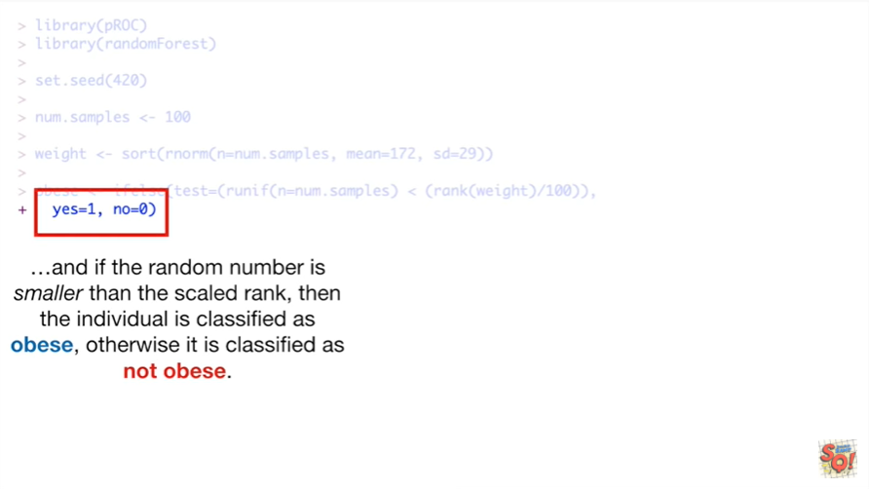

and if the random number is smaller than the scaled rank then the individual is classified as obese, otherwise it is classified as not obese.

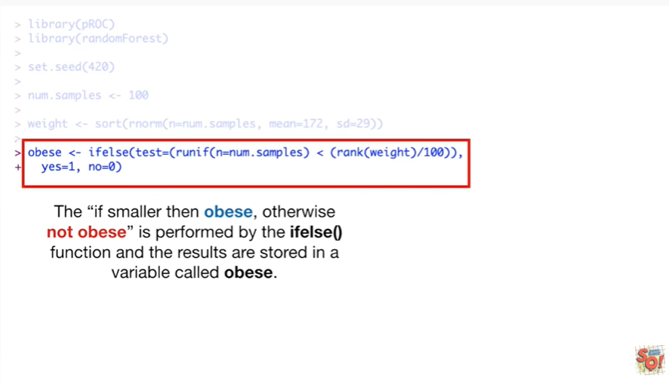

The if smaller than obese otherwise not obese is performed by the if-else function and the results are stored in a variable called obese.

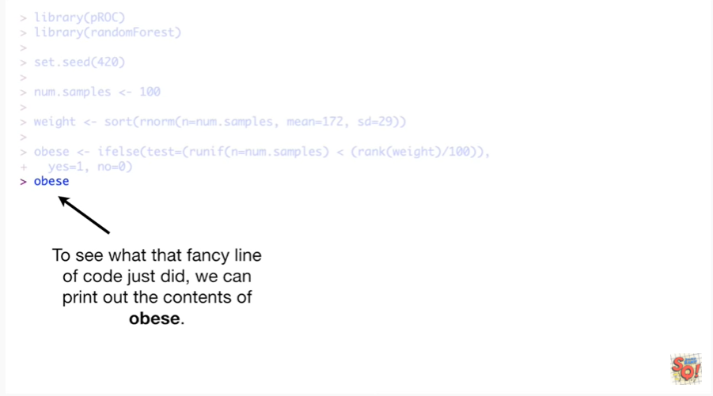

To see what that fancy line of code just did we can print out the contents of obese.

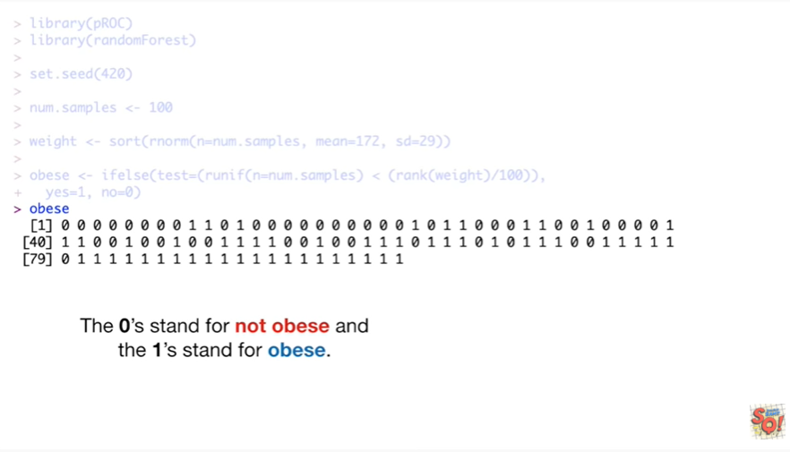

The zeroes stand for not obese and the ones stand for obese.

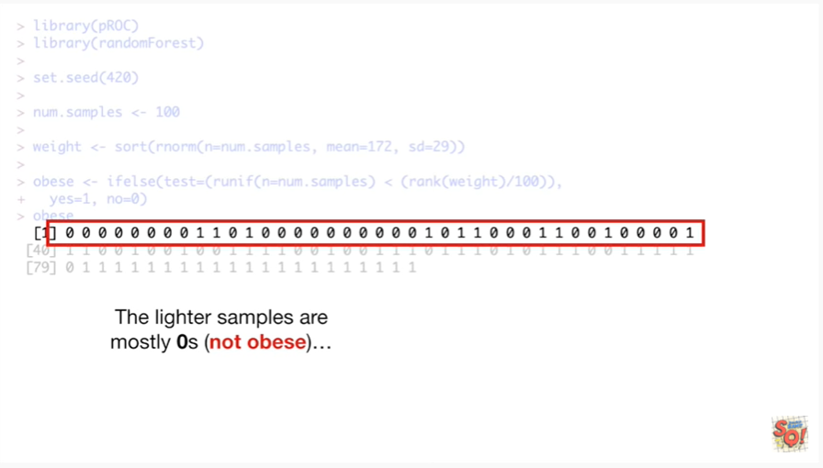

The lighter samples are mostly zeros not obese

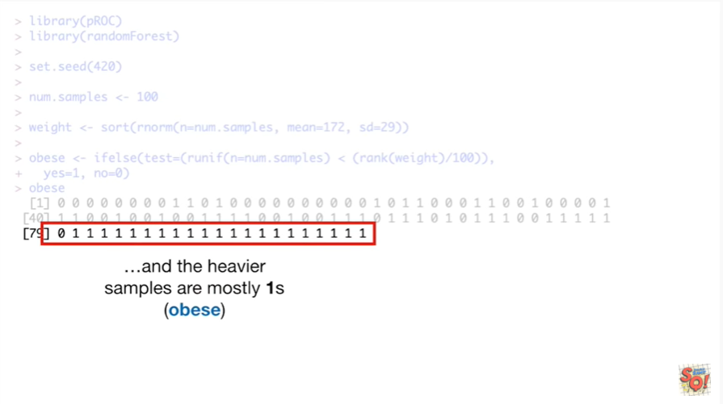

and the heavier samples are mostly wands obese.

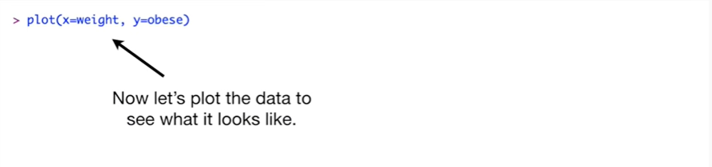

Now let's plot the data to see what it looks like.

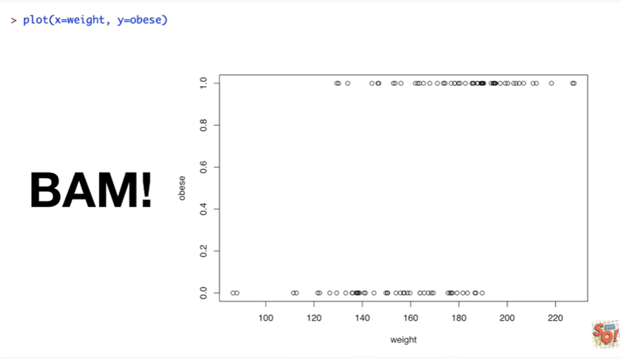

BAM !

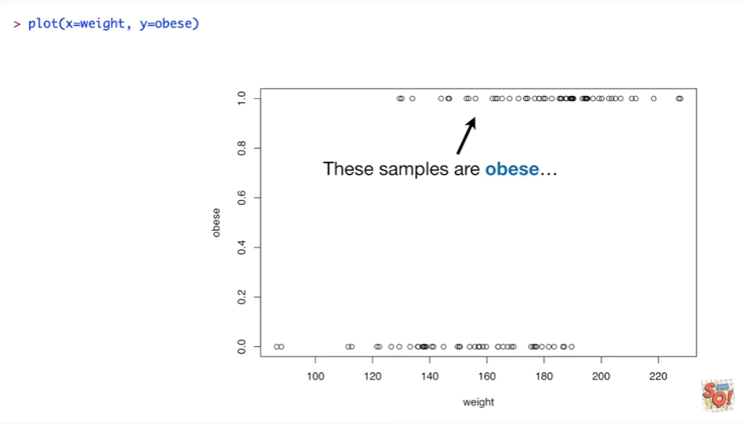

These samples are obese

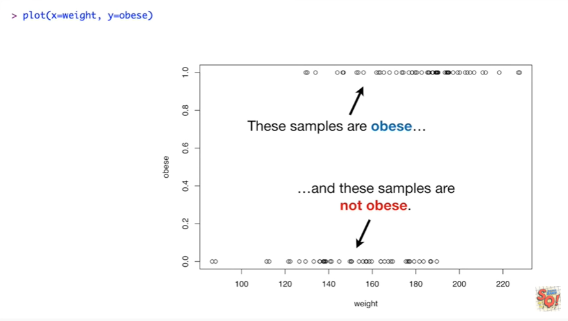

and these samples are not obese.

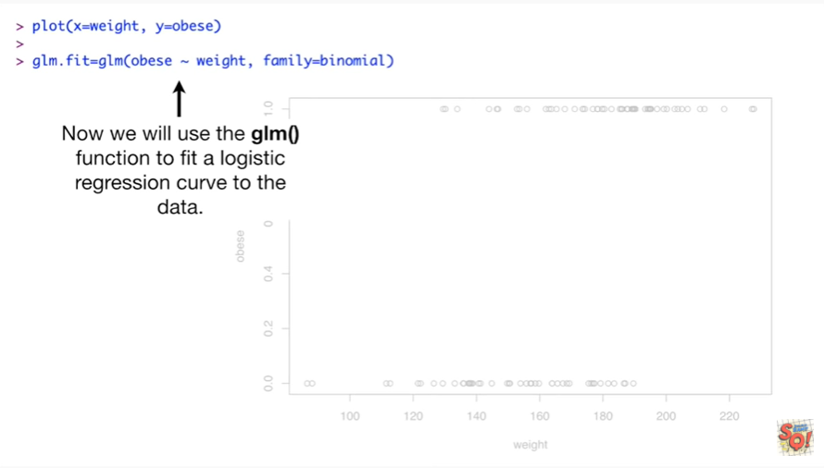

Now we will use the GLM function to fit a logistic regression curve to the data.

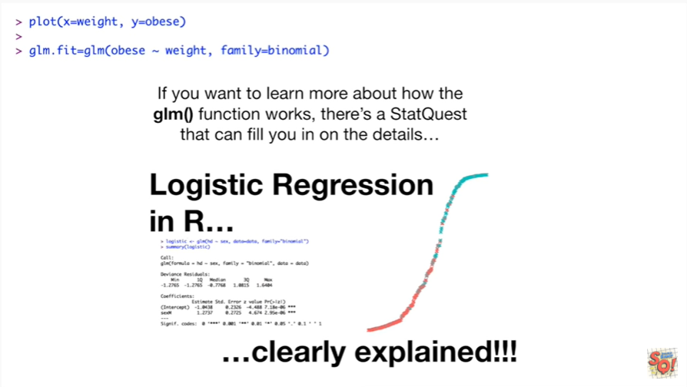

If you want to learn more about how the GLM function works there's a stat quest that can fill you in on the details.

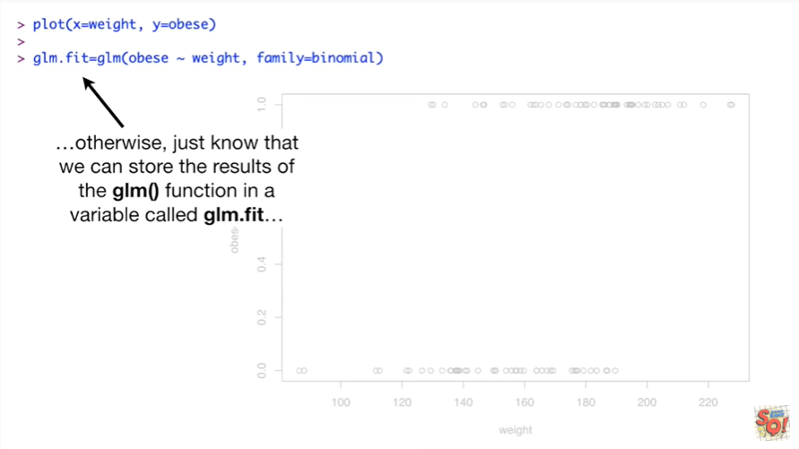

Otherwise just know that we can store the results of the glm() function in a variable called glm.fit

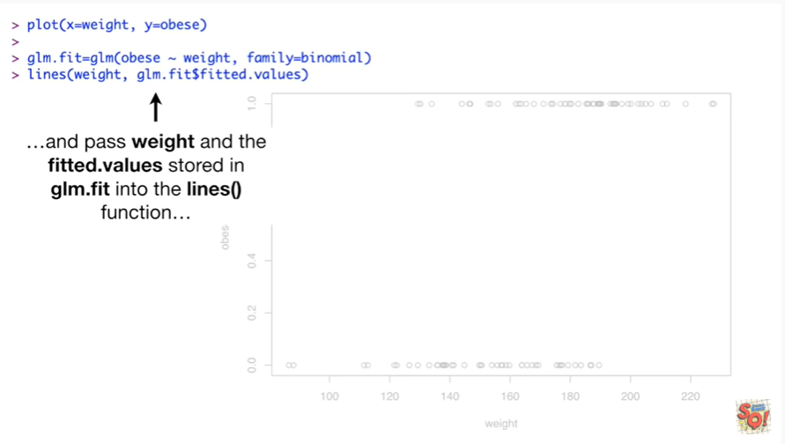

and pass weight and the fitted.values stored in glm.fit into the lines function

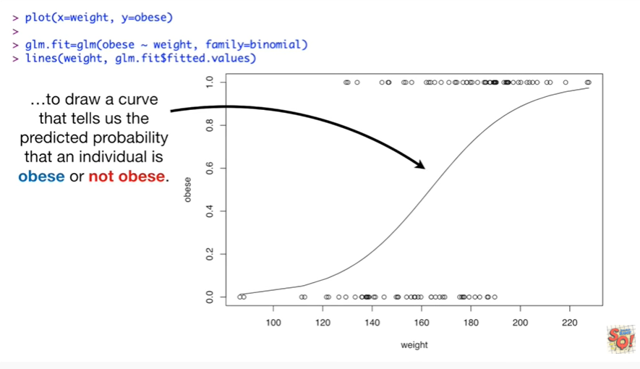

to draw a curve that tells us the predicted probability that an individual is obese or not obese.

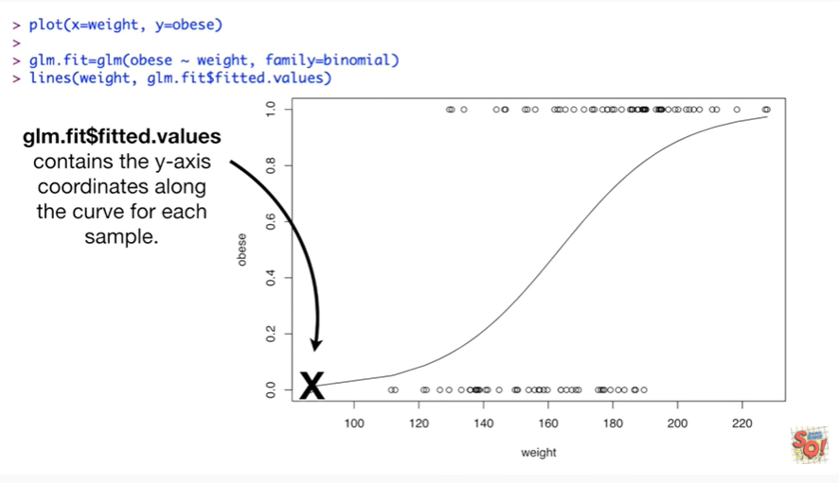

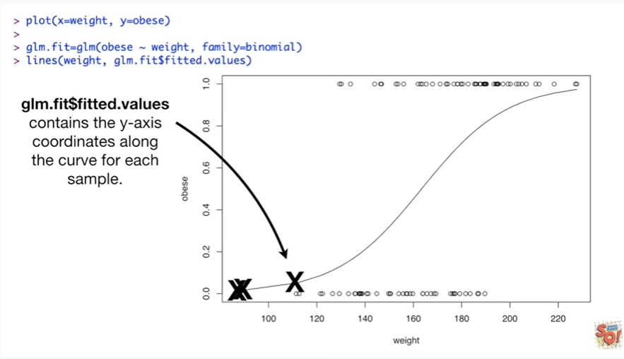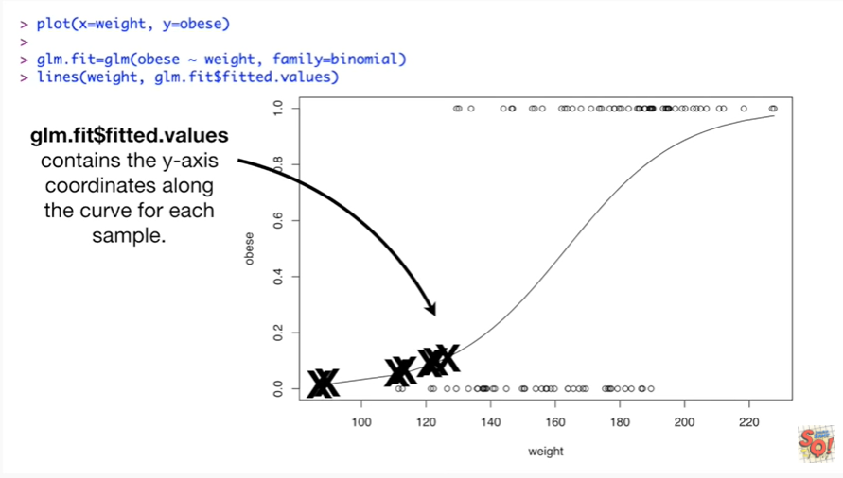

Glm.fit$fitted.values contains the y axis coordinates along the curve for each sample.

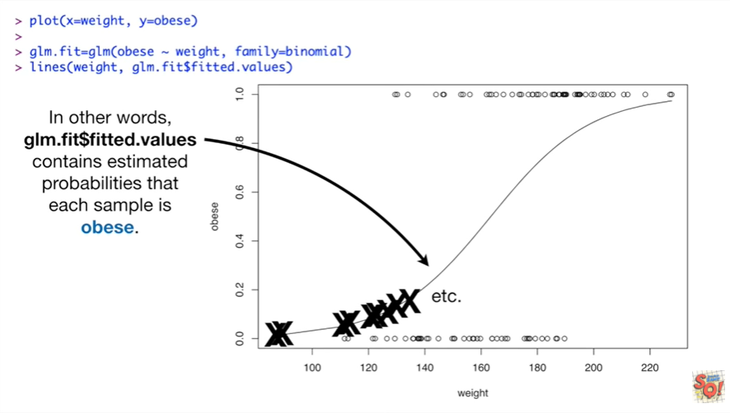

In other words GL m dot fit dollar sign fitted dot values contains estimated probabilities that each sample is obese.

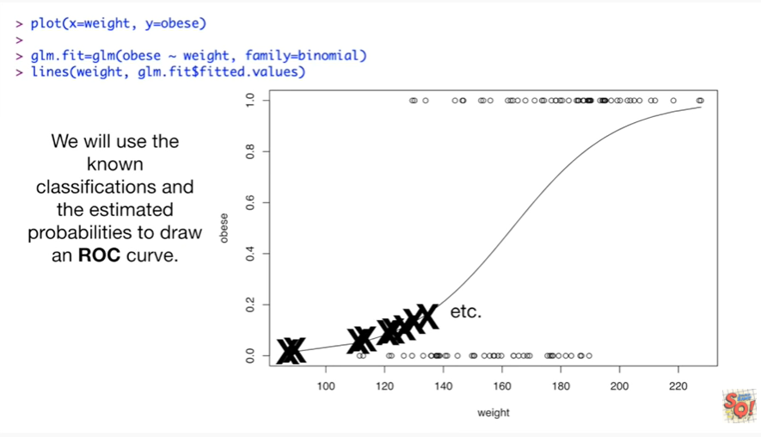

We will use the known classifications and the estimated probabilities to draw an ROC curve.

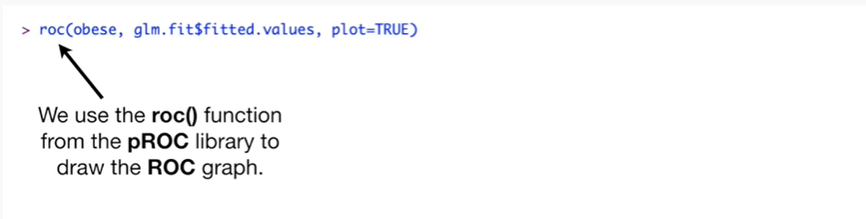

We use the roc() function from the pROC library to draw the ROC graph.

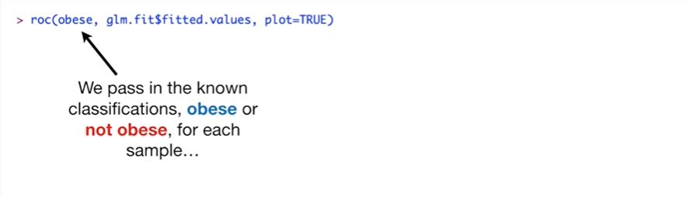

We pass in the known classifications obese or not obese for each sample

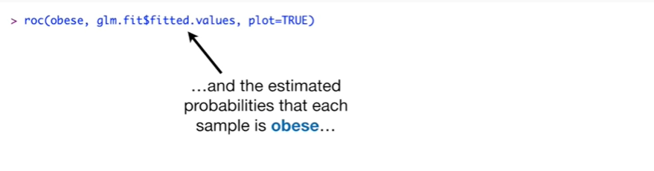

and the estimated probabilities that each sample is obese

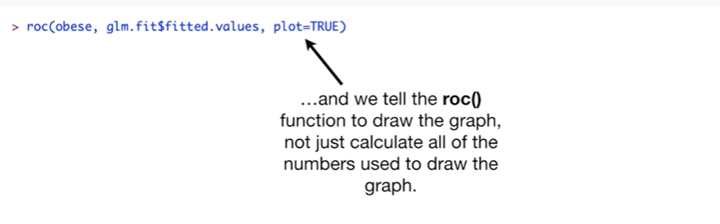

and we tell the roc() function to draw the graph not just calculate all of the numbers used to draw the graph.

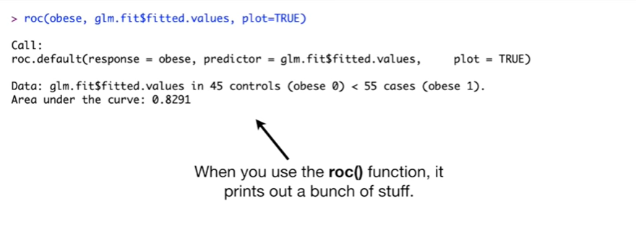

When you use the roc() function it prints out a bunch of stuff.

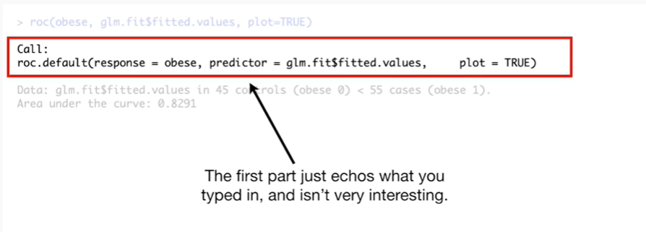

The first part just echoes what you typed in and isn't very interesting.

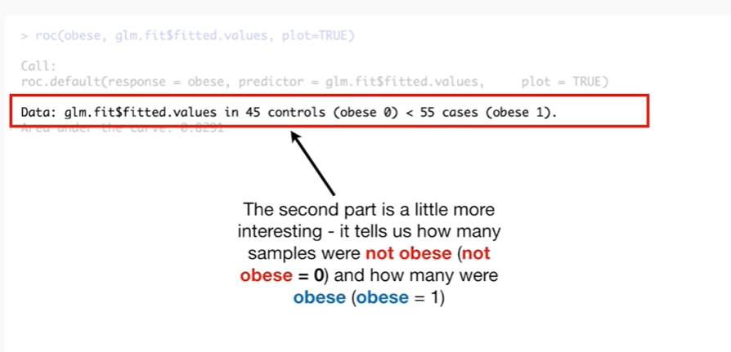

The second part is a little more interesting it tells us how many samples were not obese remember not obese equals zero and how many samples were obese obese equals one.

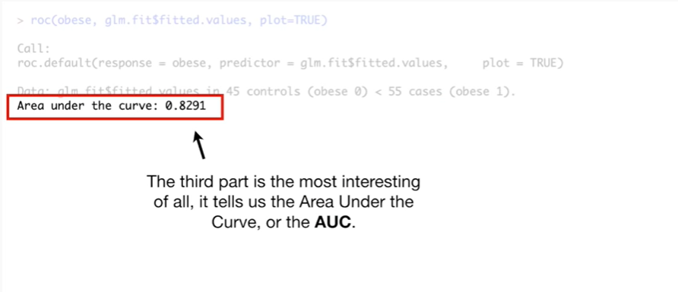

The third part is the most interesting of all it tells us the area under the curve or the AUC.

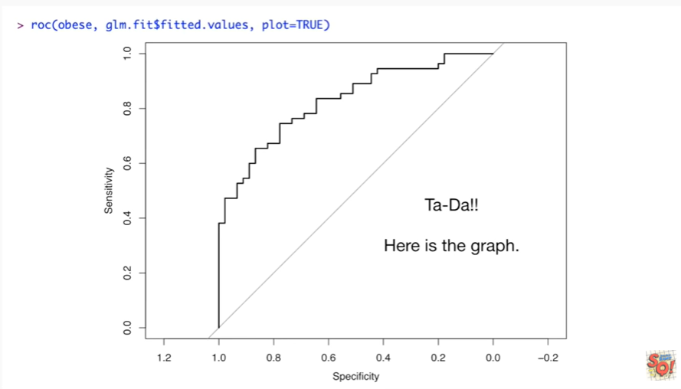

Tada…

Here's the graph.

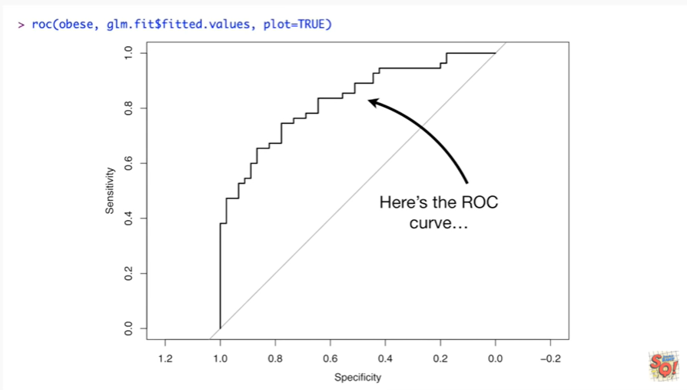

Here's the ROC curve

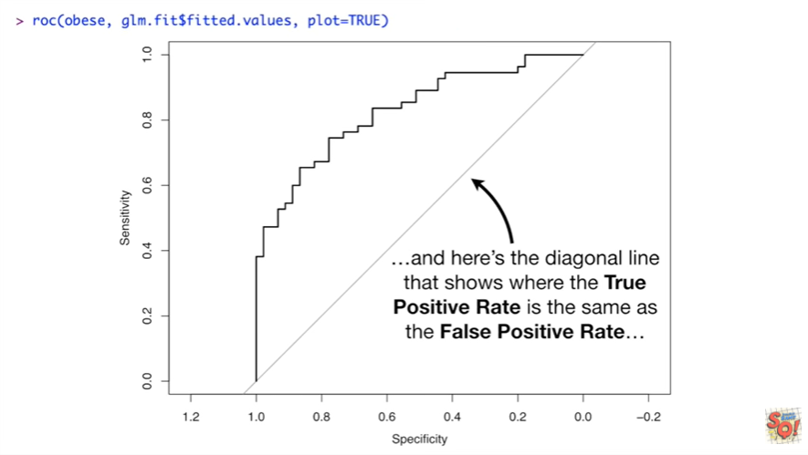

and here's the diagonal line that shows where the true positive rate is the same as the false positive rate.

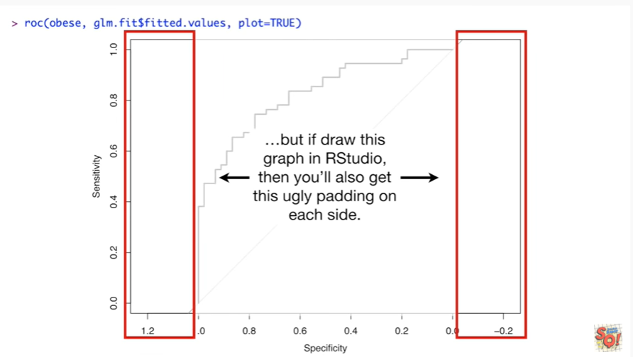

But if you draw this graph in RStudio, then you'll also get this ugly padding on each side.

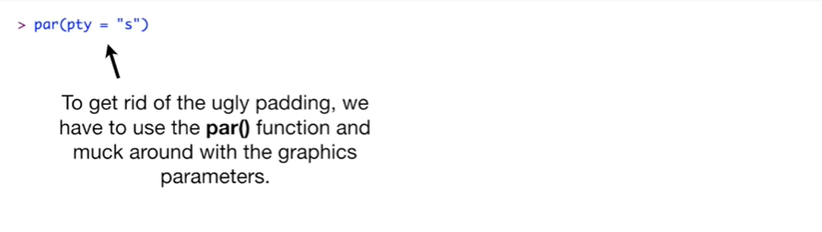

To get rid of the ugly padding we have to use the par function and muck around with the graphics parameters.

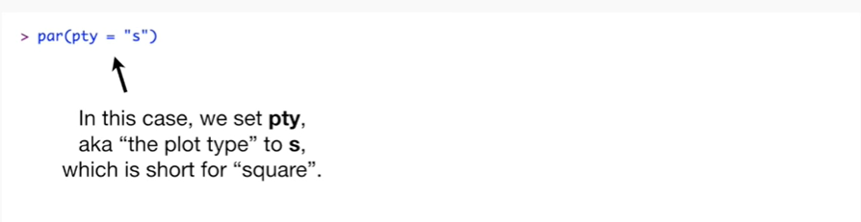

In this case we set pty, aka « the plot type » to s, which is short for « square ».

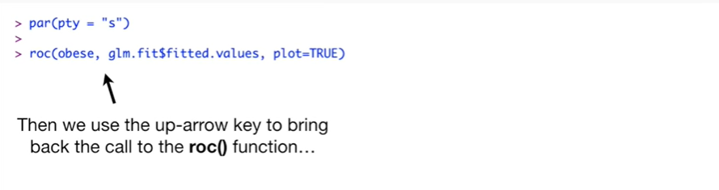

Then we use the up arrow key to bring back the call to the roc() function

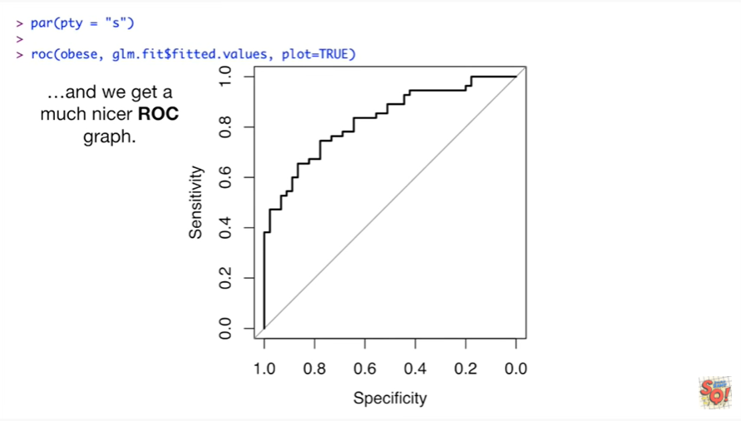

and we get a much nicer ROC graph.

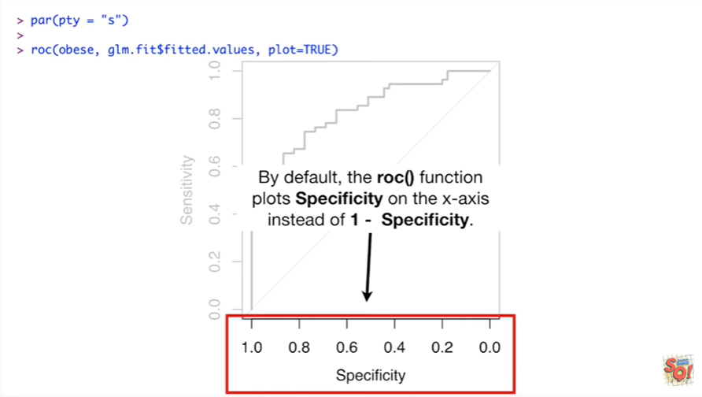

By default the ROC function plots specificity on the x-axis instead of one – specificity.

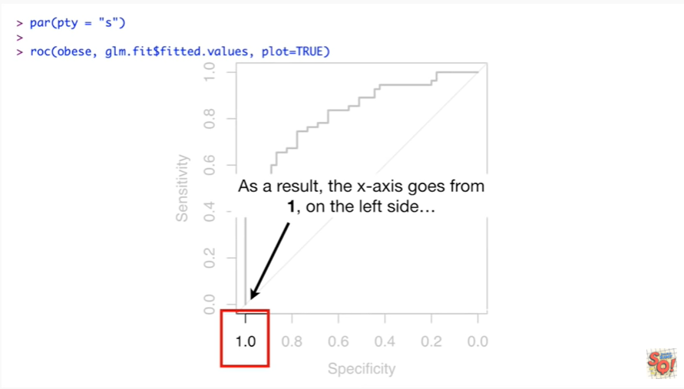

As a result the x-axis goes from one on the left side

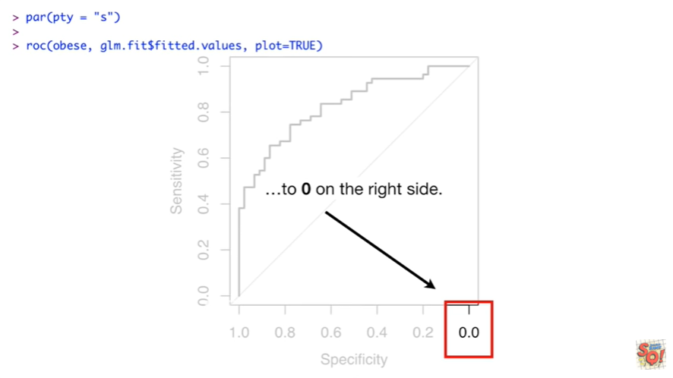

to zero on the right side.

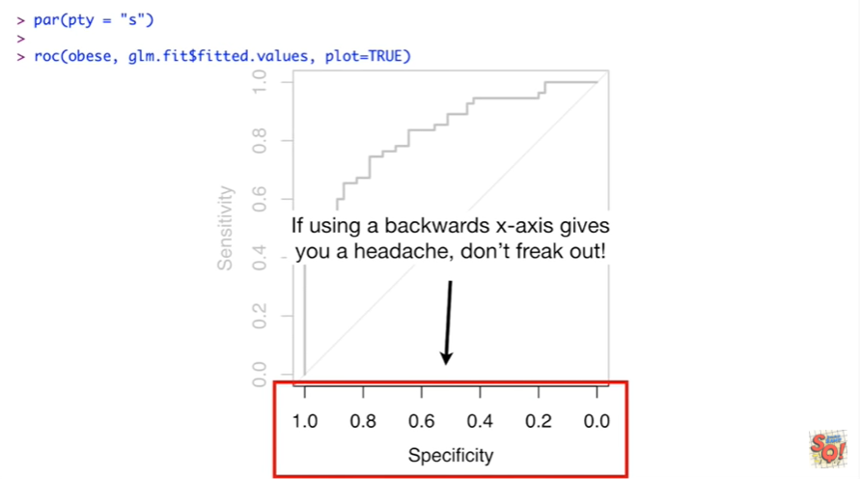

If using a backwards X access gives you a headache don't freak out.

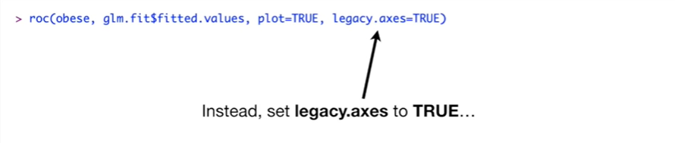

Instead said legacy taxis to true

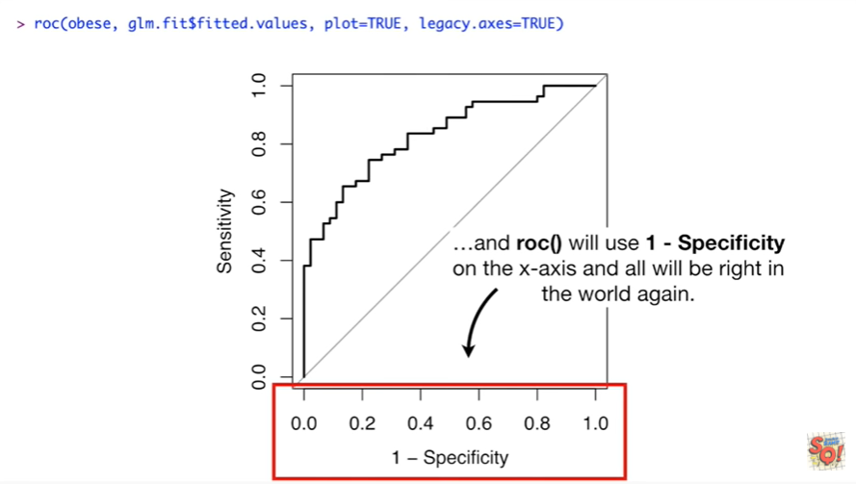

and the roc() function who will use one - specificity on the x-axis and all will be right in the world again.

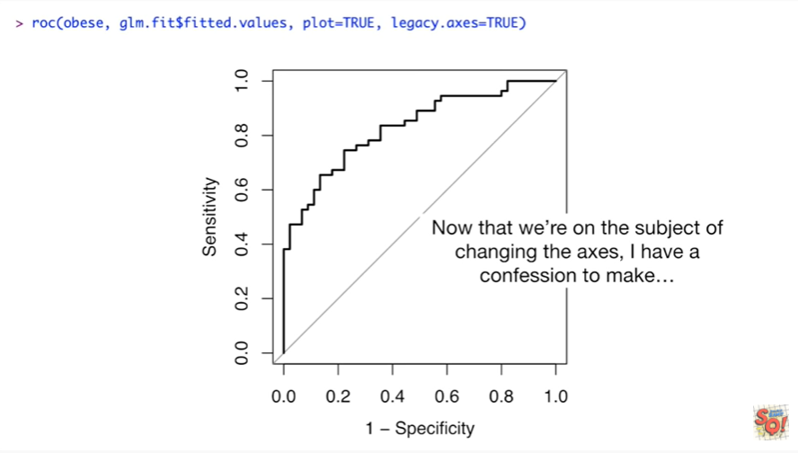

Now that we're on the subject of changing the axes I have a confession to make.

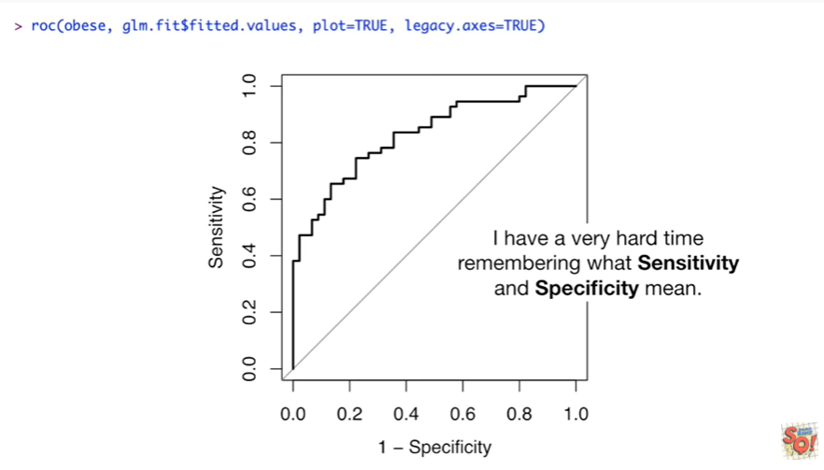

I have a very hard time remembering what sensitivity and specificity mean.

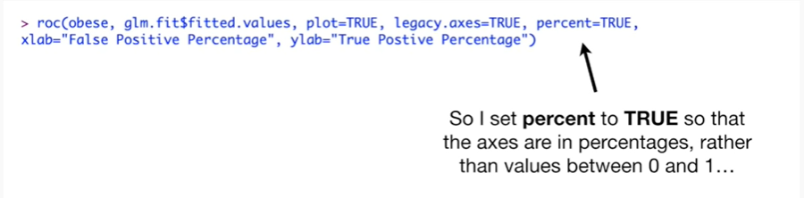

So I set percent to true so that the axes are in percentages rather than values between zero and one

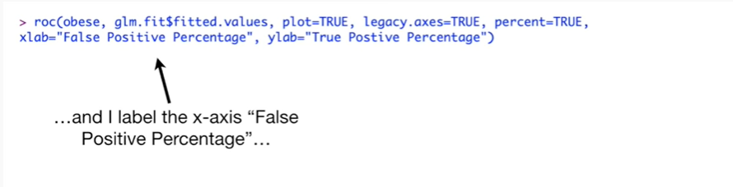

and I label the x-axis false positive percentage

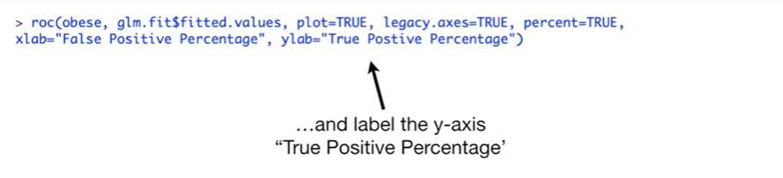

and label the y-axis true positive percentage.

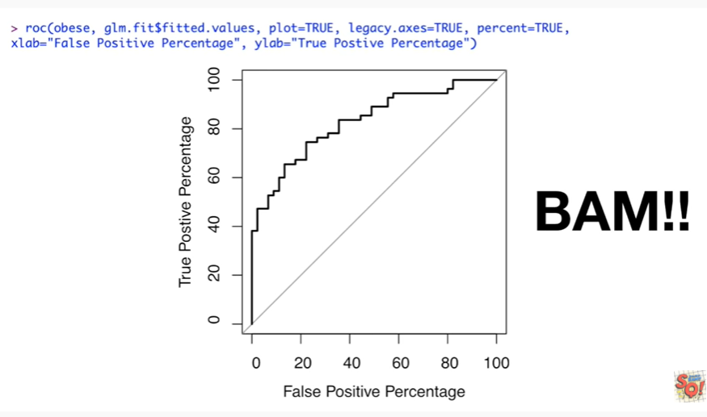

BAM !!

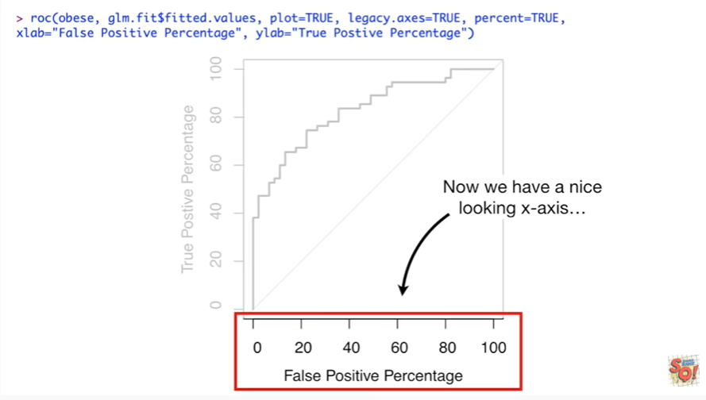

Now we have a nice-looking x-axis

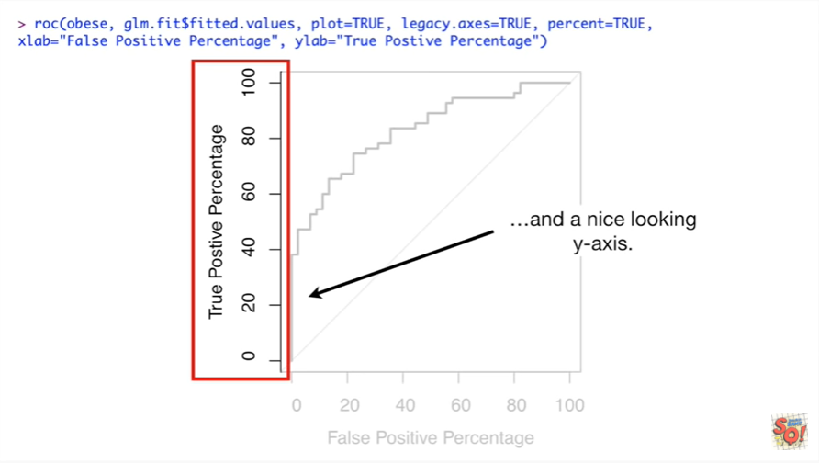

and a nice-looking y-axis.

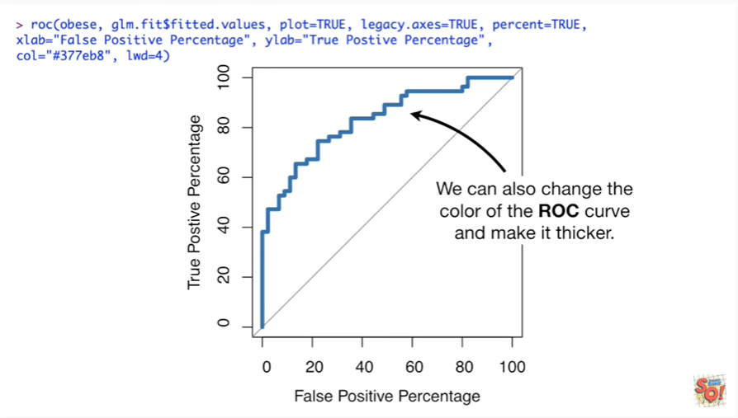

We can also change the color of the ROC curve and make it thicker.

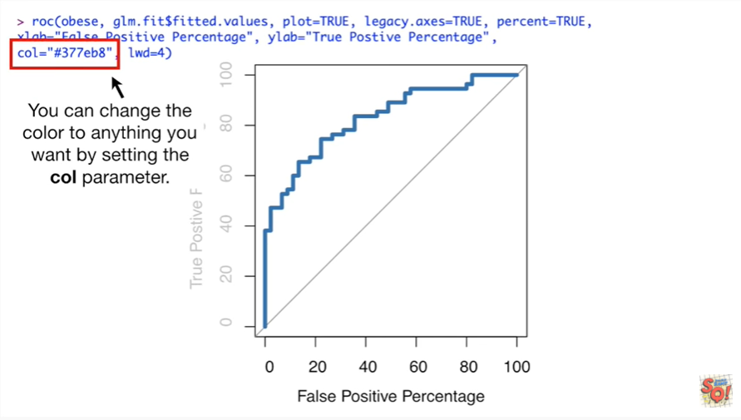

You can change the color to anything you want by setting the call parameter.

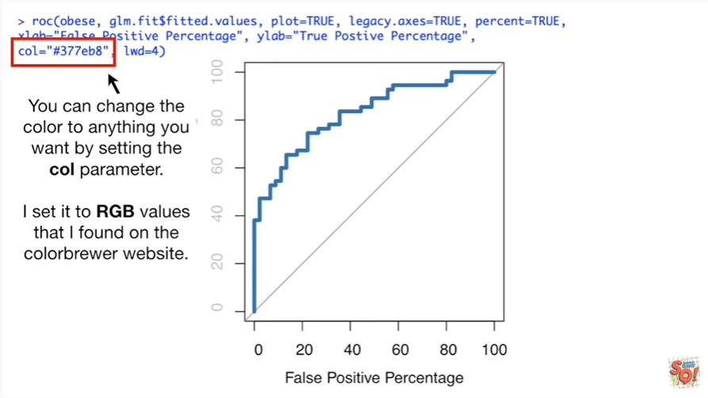

I set it to RGB values that I found on the color Brewer website.

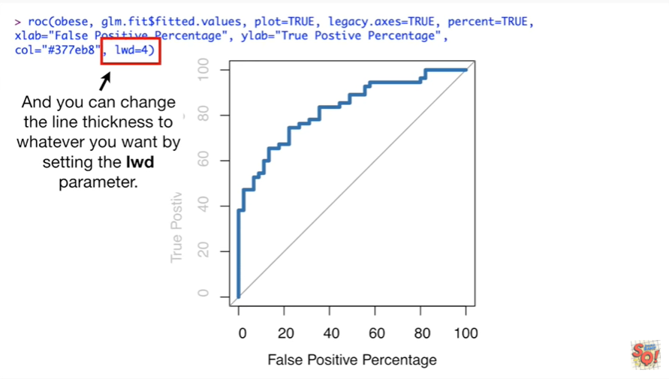

And you can change the line thickness to whatever you want by setting the lwd parameter.

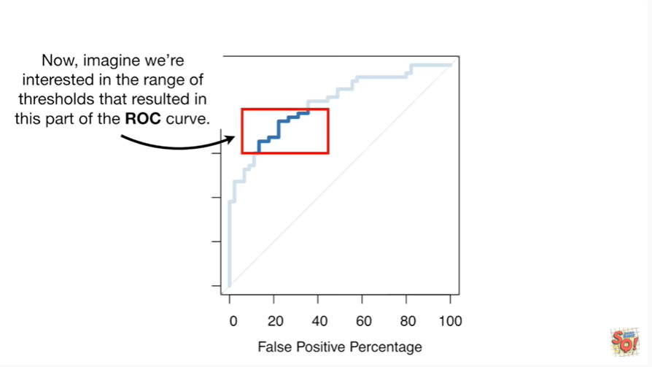

Now imagine were interested in the range of thresholds that resulted in this part of the ROC curve.

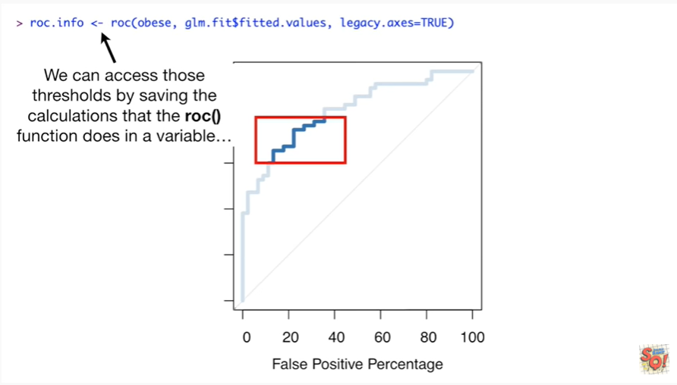

We can access those thresholds by saving the calculations that the ROC function does in a variable

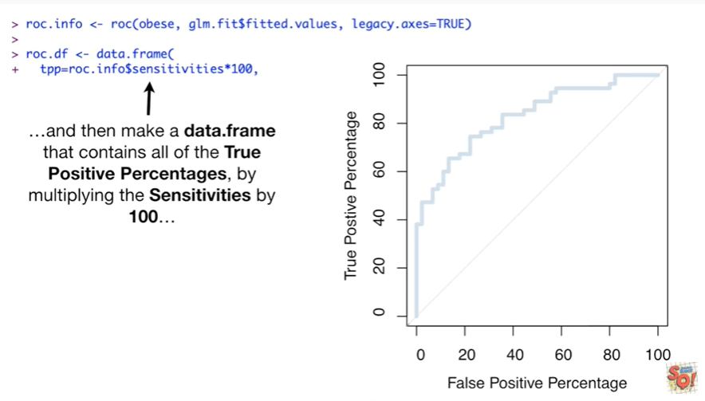

and then make a data frame that contains all of the true positive percentages by multiplying the sensitivities by 100

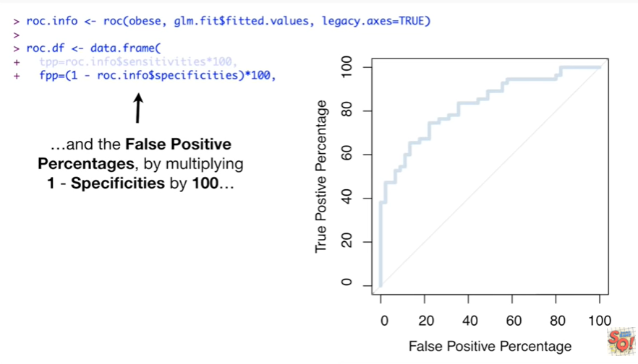

and the false positive percentages by multiplying 1 minus specificities by 100

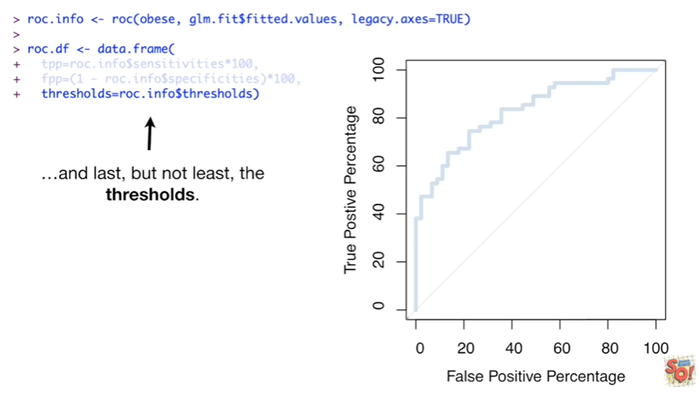

and last but not least the thresholds.

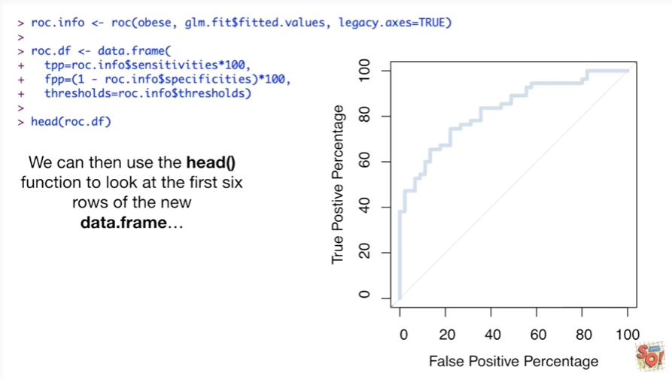

We can then use the head function to look at the first six rows of the new data frame

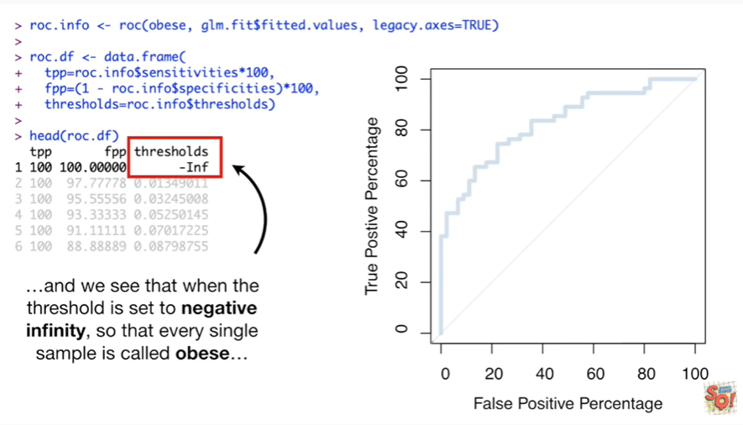

and we see that when the threshold is set to negative infinity so that every single sample is called obese

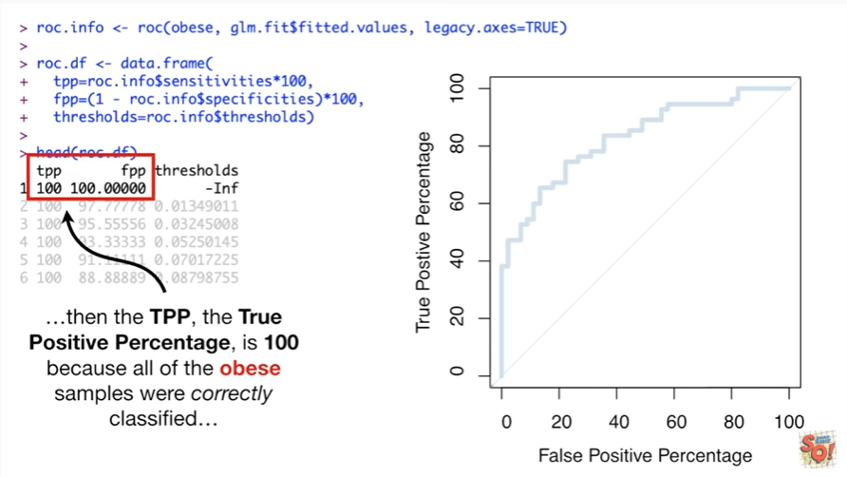

then the TPP the true positive percentage is 100 because all of the obese samples were correctly classified

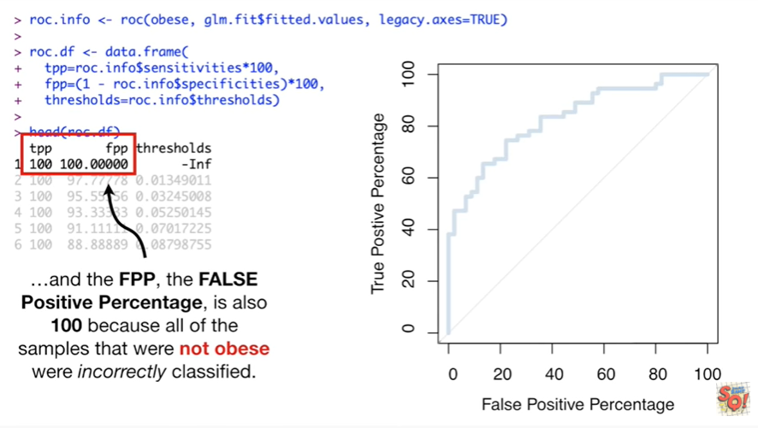

and the fpp the false positive percentage is also 100 because all of the samples that were not obese were incorrectly classified.

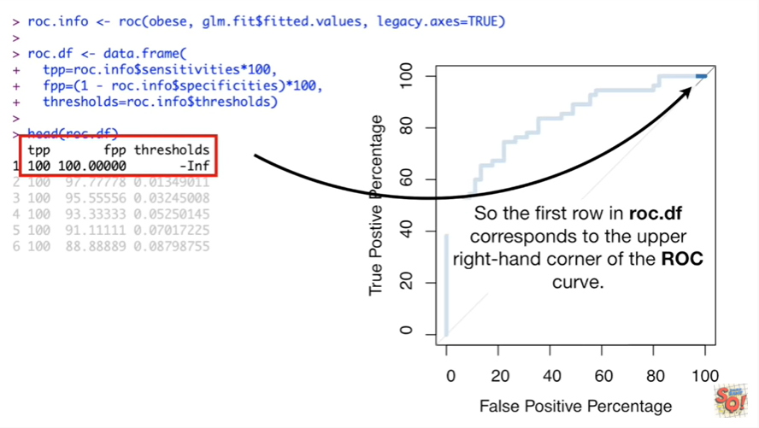

So the first row in roc DF corresponds to the upper right hand corner of the ROC curve.

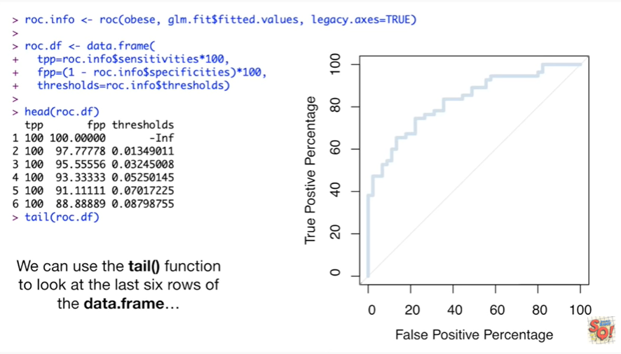

We can use the tail function to look at the last six rows of the data frame

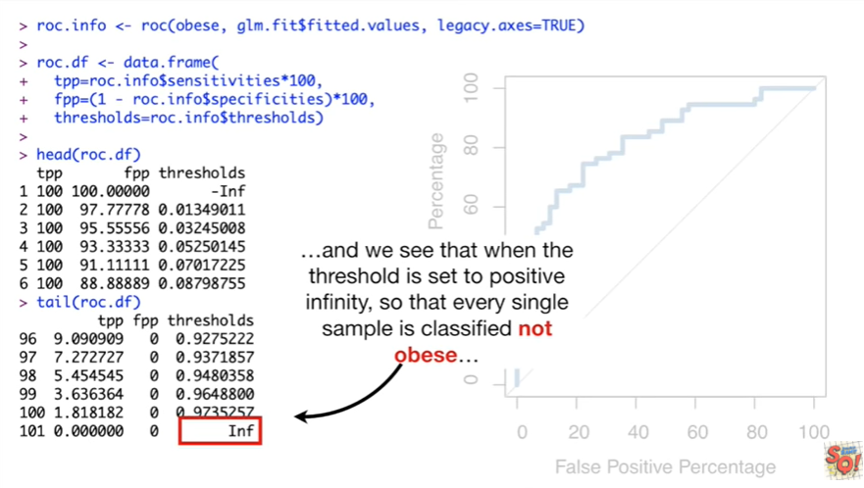

and we see that when the threshold is set to positive infinity so that every single sample is classified not obese

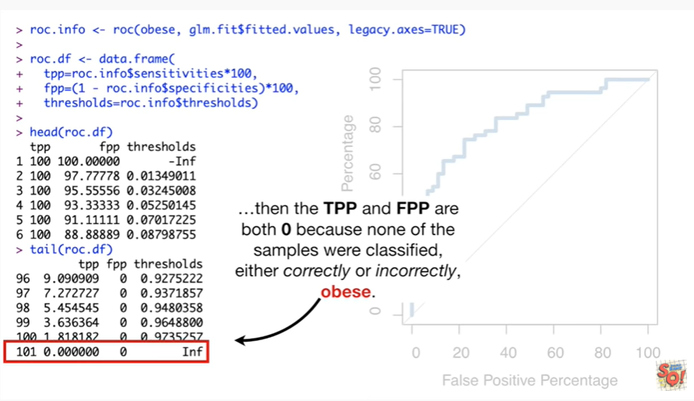

then the TPP and fpp are both zero because none of the samples were classified either correctly or incorrectly obese.

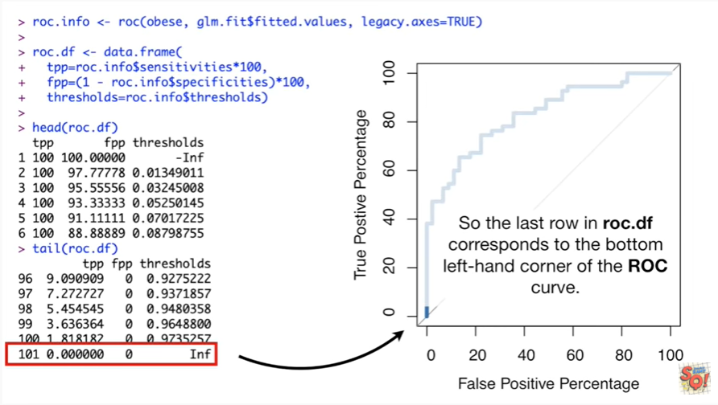

So the last row in our OCD f corresponds to the bottom left-hand corner of the ROC curve.

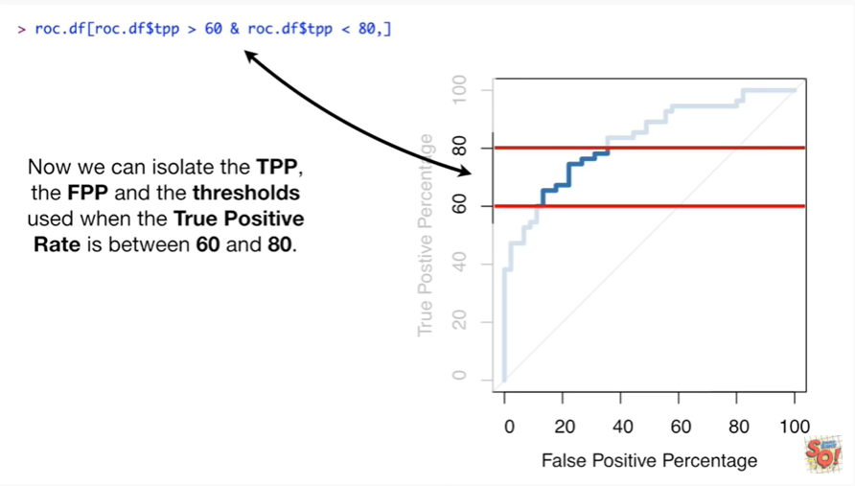

Now we can isolate the TPP the fpp and the thresholds used when the true positive rate is between 60 and 80.

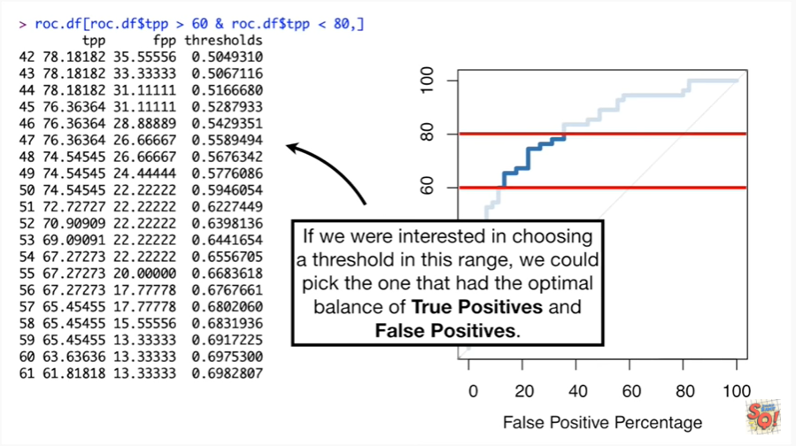

If we were interested in choosing a threshold in this range we could pick one that had the optimal balance of true positives and false positives.

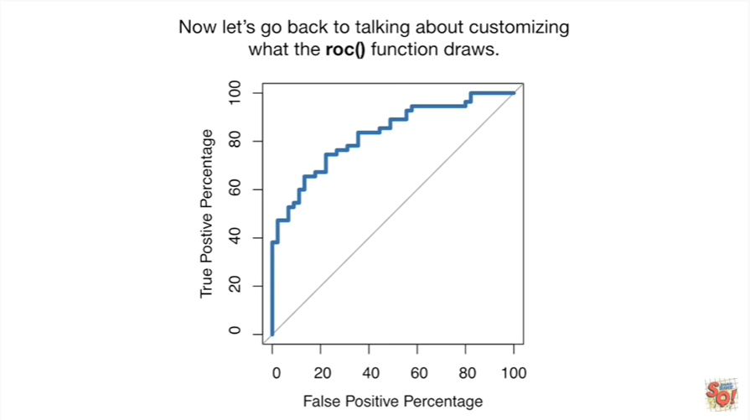

Now let's go back to talking about customizing with the ROC function drawers.

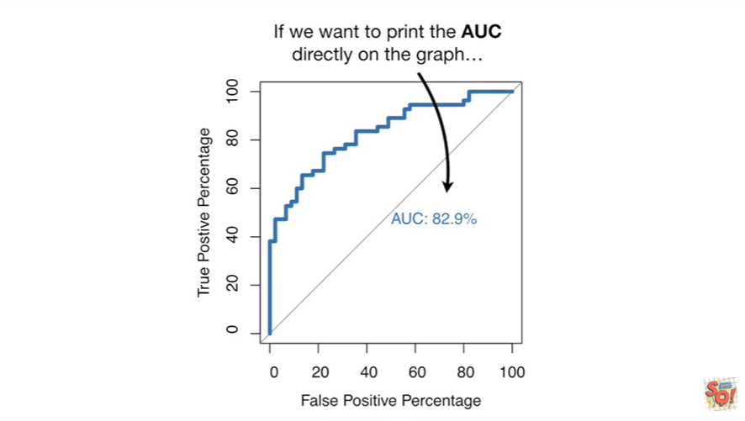

If we want to print the AUC directly on the graph

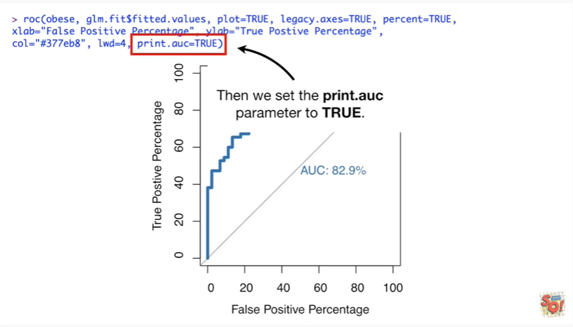

then we set the print auc parameter to true.

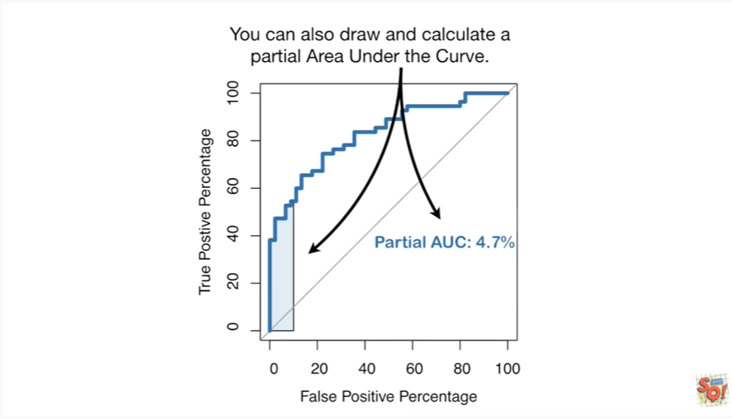

You can also draw and calculate a partial area under the curve.

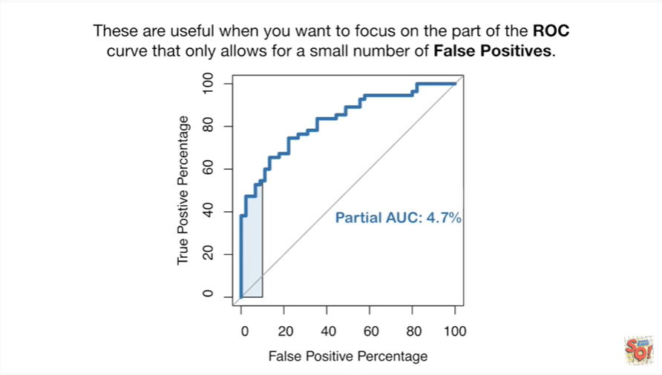

These are useful when you want to focus on the part of the ROC curve that only allows for a small number of false positives.

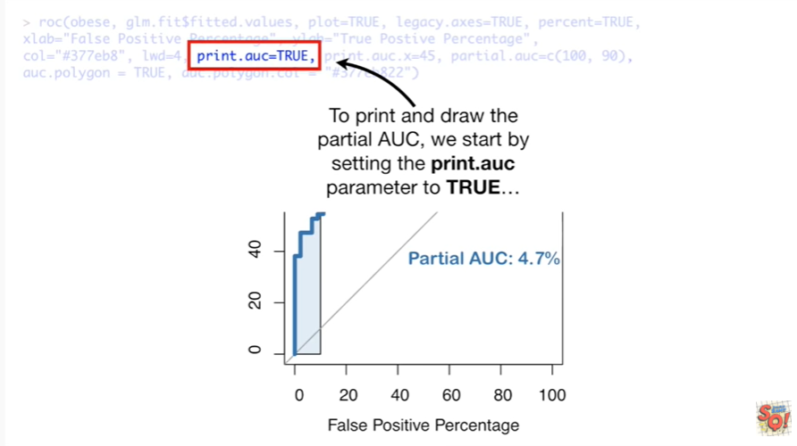

To print and draw the partial a you see we start by setting the print a you see parameter to true

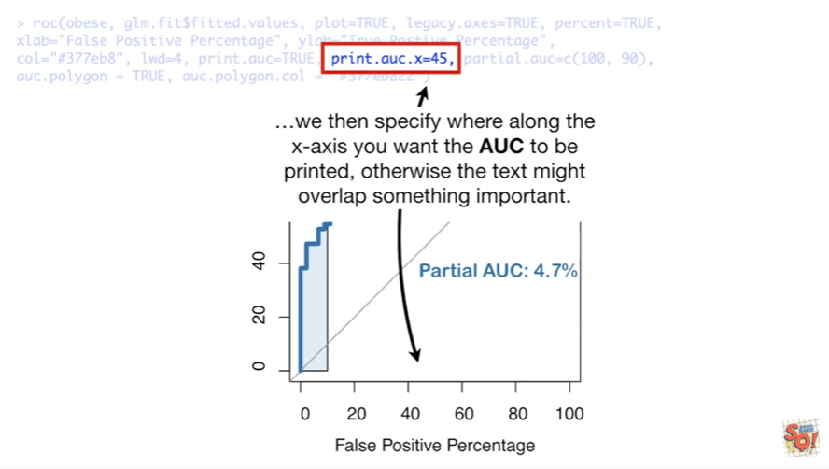

we then specify where along the x-axis you want the AUC to be printed otherwise the text might overlap something important.

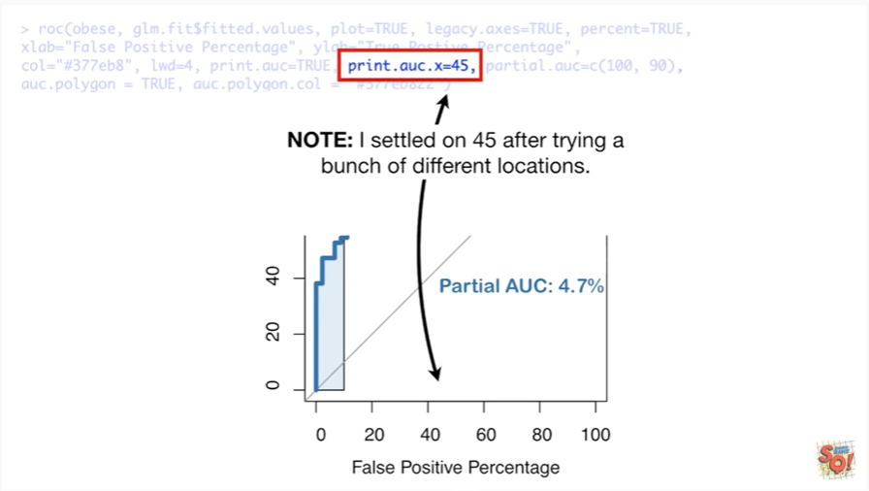

Note : I settled on 45 after trying a bunch of different locations.

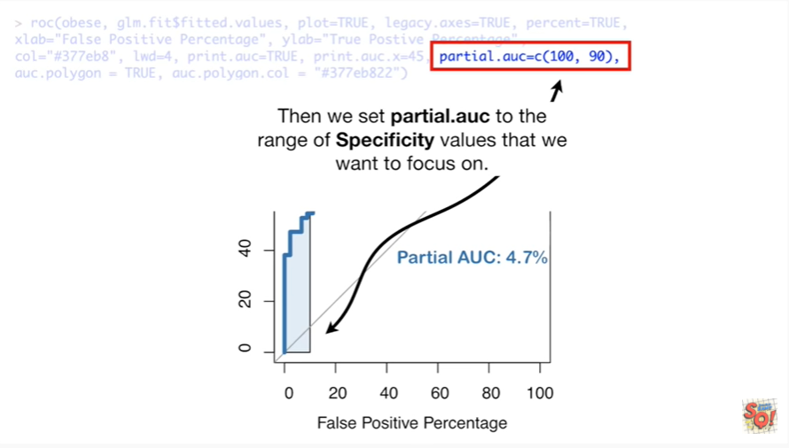

Then we set partial AUC to the range of specificity values that we want to focus on.

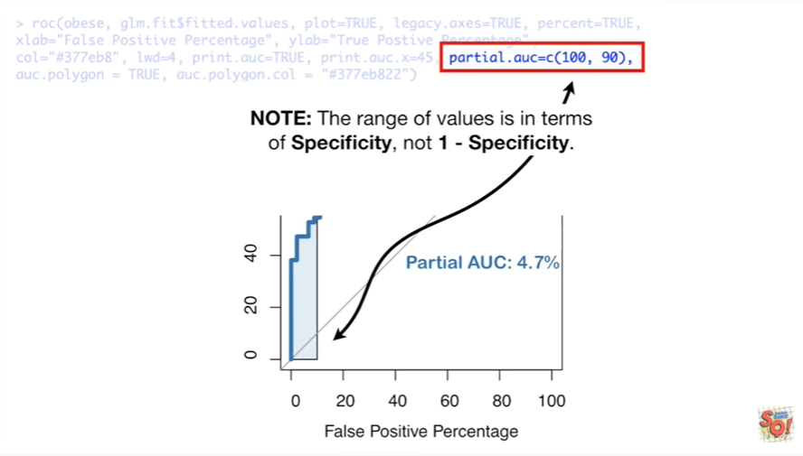

Note : the range of values is in terms of specificity not one – specificity.

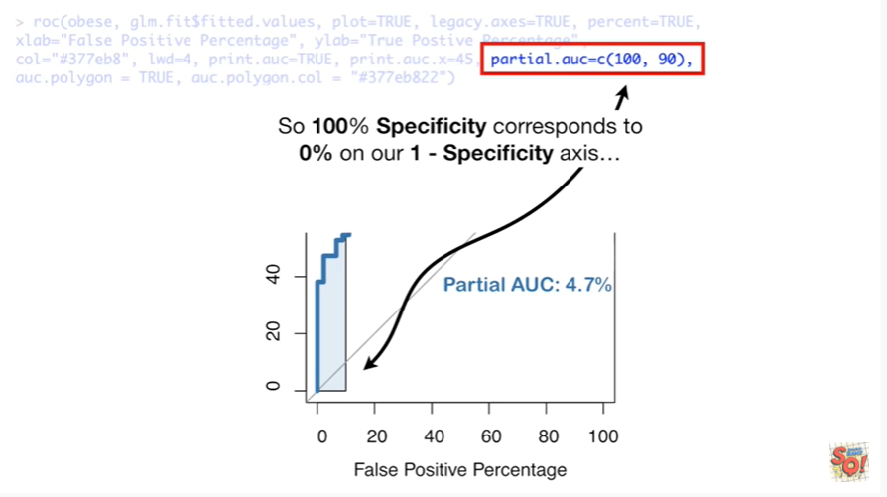

So one hundred percent specificity corresponds to zero percent on our one - specificity axis

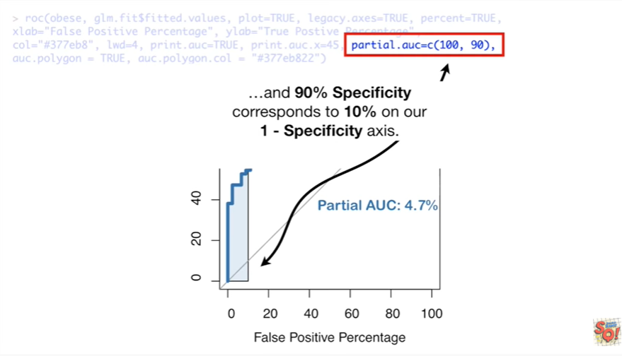

and ninety percent specificity corresponds to ten percent on our one - specificity axis.

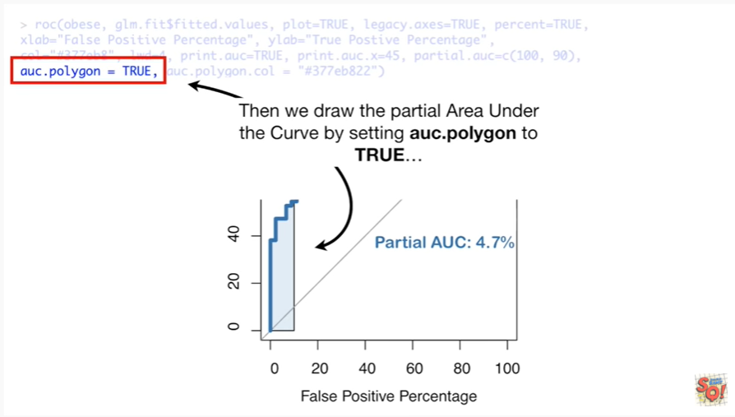

Then we draw the partial area under the curve by setting a uc.polygon to true

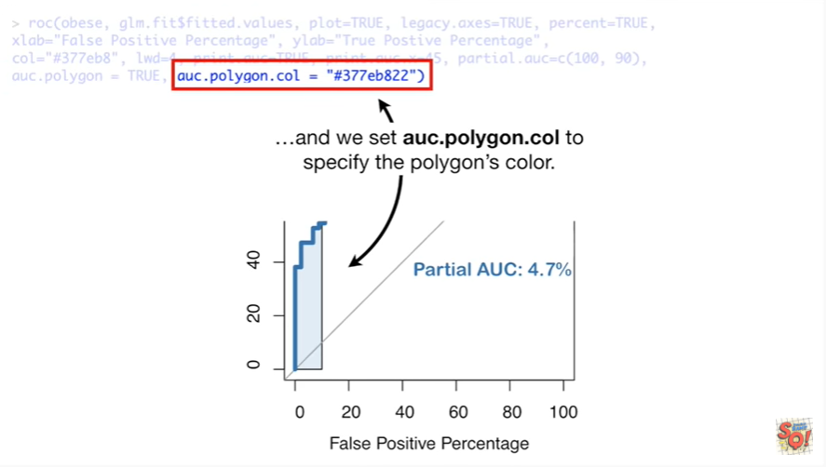

and we set a UC polygon call to specify the polygons color.

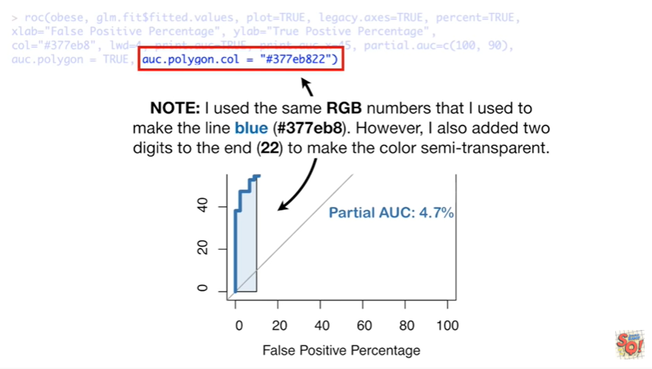

Note : I use the same RGB numbers that I used to make the line blue however I added two digits to the end to make the color semi-transparent.

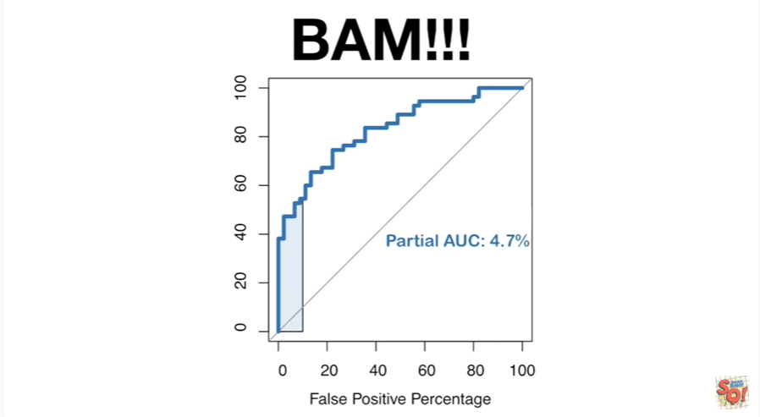

BAM !!!

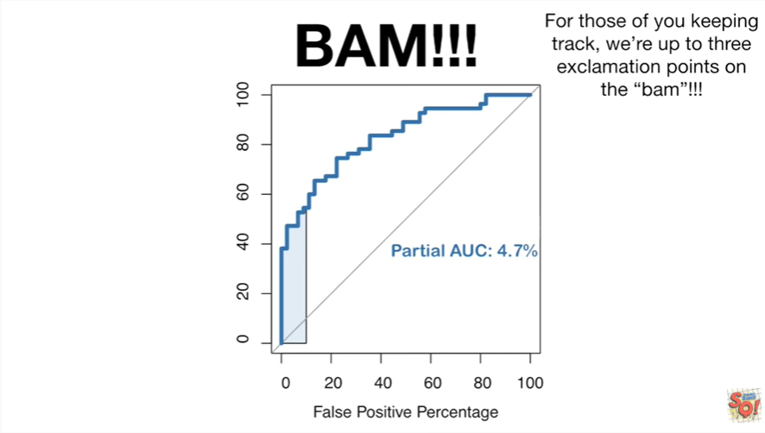

For those of you keeping track were up to three exclamation points on the BAM.

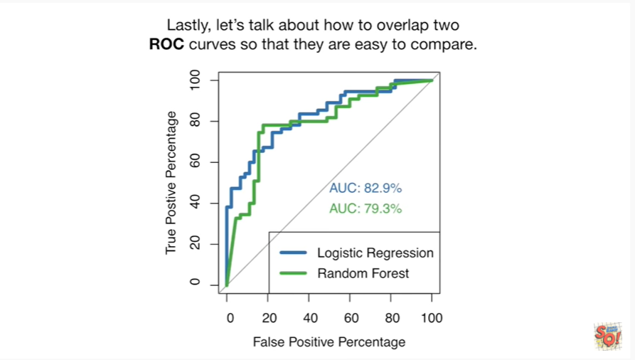

Lastly let's talk about how to overlap two ROC curves so that they are easy to compare.

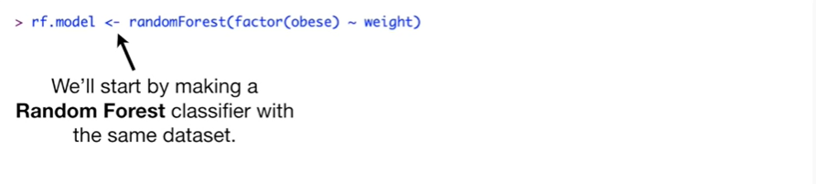

We'll start by making a random forest classifier with the same data set.

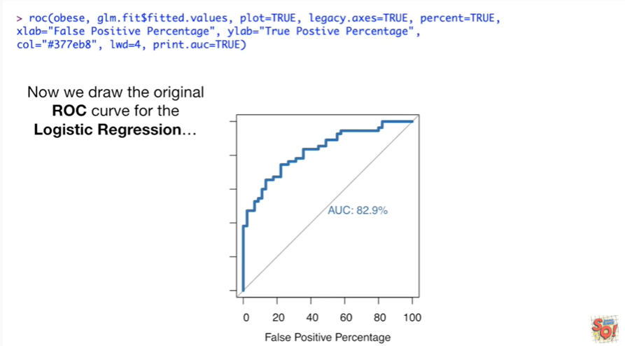

Now we draw the original ROC curve for the logistic regression

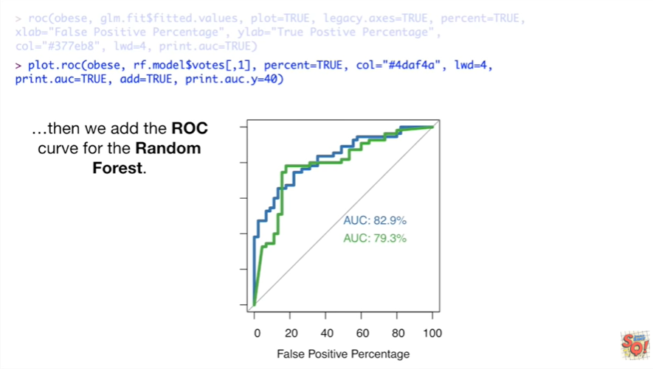

then we add the ROC curve for the random forest.

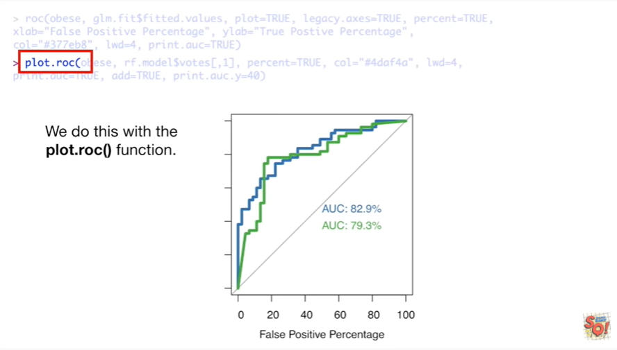

We do this with the plot.roc() function.

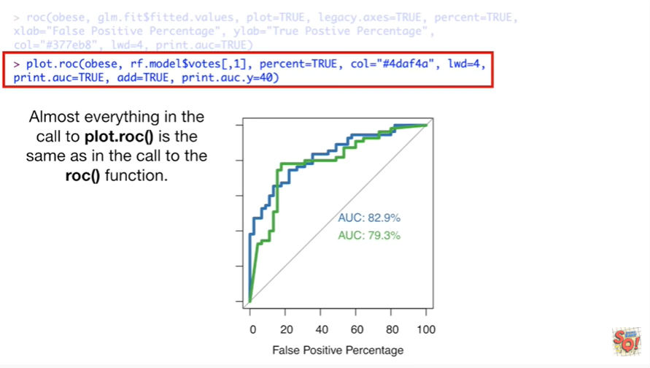

Almost everything in the call to plot.roc() is the same as in the call to the roc() function.

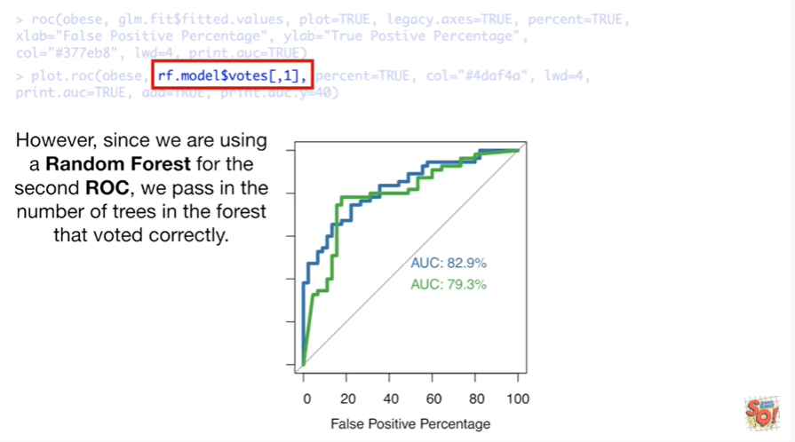

However since we are using a random forest for the second ROC we pass in the number of trees in the forest that voted correctly.

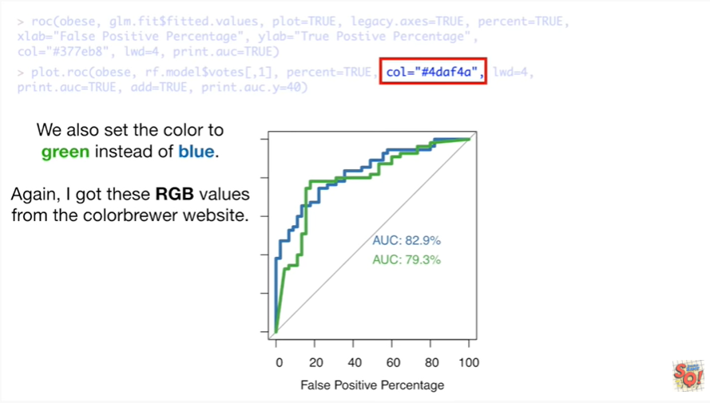

We also set the color to green instead of blue.

Again I got these RGB values from the color Brewer website.

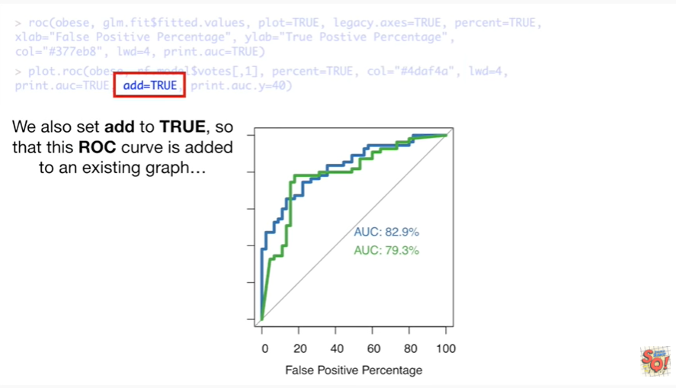

We also set ad to true so that this ROC curve is added to an existing graph

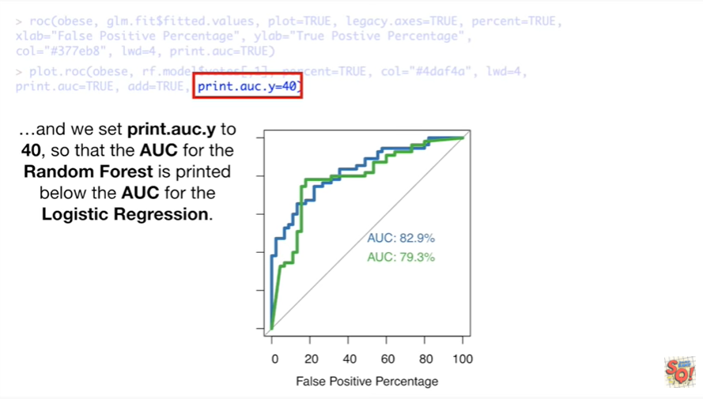

and we set print.auc.y to 40 so that the AUC for the random forest is printed below the AUC for the logistic regression.

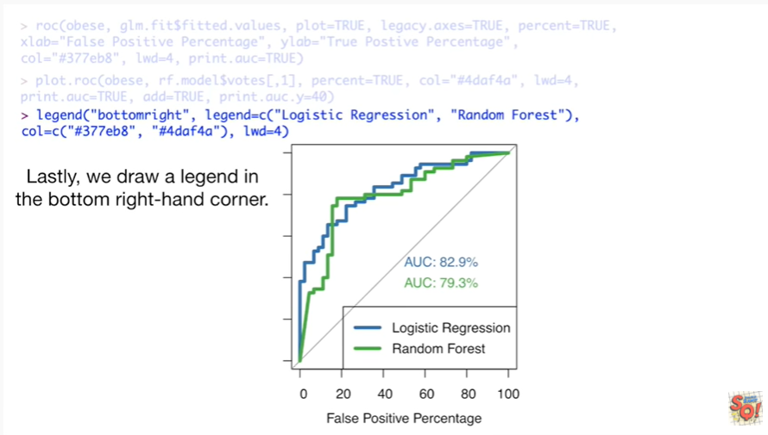

Lastly we draw legend in the bottom right hand corner.

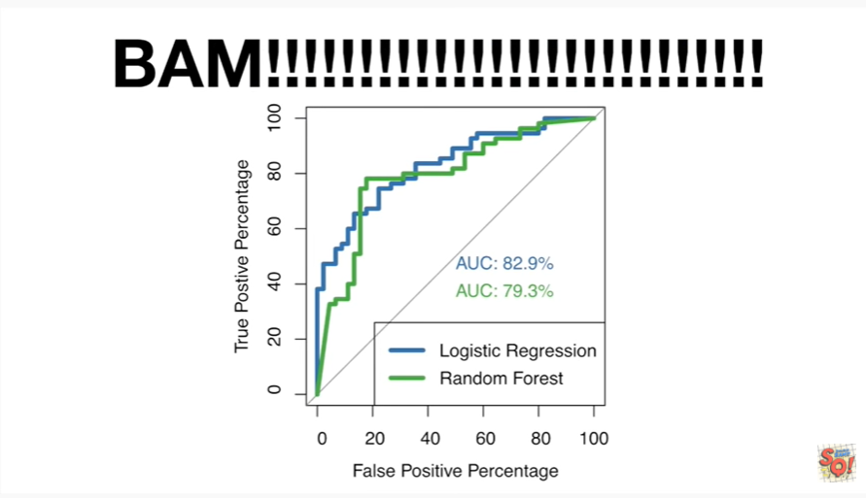

BAM !!!!!!!!!!!!!!!!!!

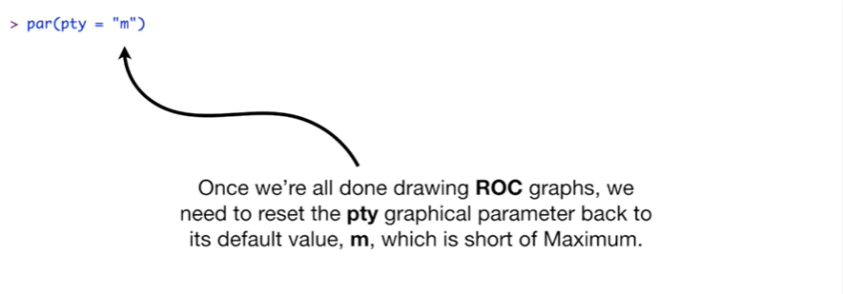

Once we're all done drawing ROC graphs we need to reset the pty graphical parameter back to its default value m which is short for maximum.



As in use the maximum amount of space provided to draw graphs.